##### 4.2.1.2 Manage Supplier

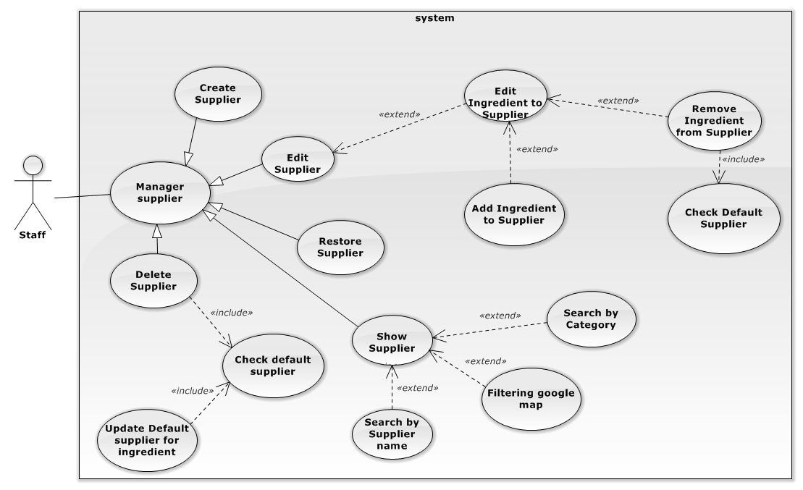

Figure 4-2: Manage Supplier Use case

##### 4.2.1.2.1 Create new Supplier

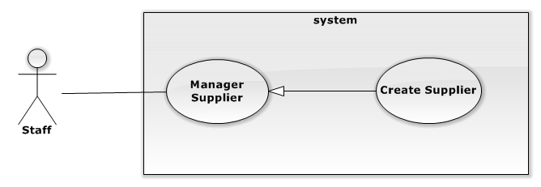

Figure 4-3: Create new supplier Use case

| **USE CASE SPECIFICATION** | | | |
| --- | --- | --- | --- |
| **Use-case No.** |  | **Use-case Version** | 1.0 |
| **Use-case Name** | Create new supplier | | |
| **Author** | Phạm Văn Duy | | |
| **Date** |  | **Priority** | Medium |
| **Actor:**  Staff  **Summary:**  Staff creates new supplier  **Goal:**  The purpose of Create new supplier use case is allowed Staff to request for creating new supplier in the system.  **Triggers:**  Staff wants to create new supplier  Staff clicks on “Nhà cung cấp” menu on menu bar and then click on the “Thêm mới” button.  **Preconditions:**  User must logged-in as Staff-role.  **Post Conditions:**  **Success:**   * The Staff is presented with an success message on screen.   **Failure:**   * The Staff is presented with an error message on screen.   **Main Success Scenario:**   |  |  | | --- | --- | | Actor Actions | System Response | | 1. Staff click on the “Nhà cung cấp” menu on menu bar.     3. Staff clicks on “Thêm mới” button.  5. Staff fills suplier information form and clicks on “Thêm” button. | 1. Redirect to “Nhà cung cấp” page   4. The pop up “Thêm nhà cung cấp” is displayed on screen. Supplier information form includes:   * “Tên” [Name of supplier, Textbox, max length: 100, require] * “Số điện thoại”[Phone number, Textbox, regular expression: (^[0-9]{10,11}$), require] * “Danh mục”[Category of Supplier, Dropdown list include all category available] * “Địa chỉ”[Address, Textbox, The under is google map for staff choose address] * “Thêm” button.     [Exception 1] [Exception 2]  [Exception 3] [Exception 4]  [Exception 5] [Exception 6]  [Exception 7] [Exception 8]  [Exception 9]  6. The pop up is closed and message is displayed “Thêm nhà cung cấp thành công”. | |  |  |   **Alternative Scenario:**   |  |  | | --- | --- | | Actor Actions | System Response | | N/A | N/A |     **Exceptions:**   |  |  | | --- | --- | | Actor Actions | System Response | | [Exception 1]  1. Supplier’s “Tên” is missing.  [Exception 2]  1. The length of Supplier’s “Tên” is out of range.  [Exception 3]  1. Supplier’s Name is exist.    [Exception 3]  1. Supplier’s “Số điện thoại” is missing.  [Exception 4]   1. 1. Supplier’s “Số điện thoại” is not in correct format.   [Exception 5]  1. Supplier’s “Địa chỉ” is missing.  [Exception 6]  1. Supplier’s “Địa chỉ” is not correct.  [Exception 7]  1. System cannot create supplier.  [Exception 8]  1. System fails to load Supplier. | 2. Shows error “Không được để trống!” on textbox.   1. Shows error “Tên quá dài (hơn 100 ký tự) on screen.   2. Shows error “Tênnày đã tồn tại!.”) on screen.  2. Shows error “Không được để trống!” on textbox.   1. Shows error “Số điện thoại không đúng” to customer.   2. Shows error “Không được để trống!” on textbox.  2. Shows error “Địa chỉ không đúng!” on textbox.  2. Shows error ”Xảy ra lỗi, xin hay thử lại.!” on screen.    2. Show message “Hệ thống không thể kết nối với cơ sở dữ liệu.” |   **Relationships:**  N/A  **Business Rules:**  N/A | | | |
|  | | | |

##### 4.2.1.2.2 Edit Supplier

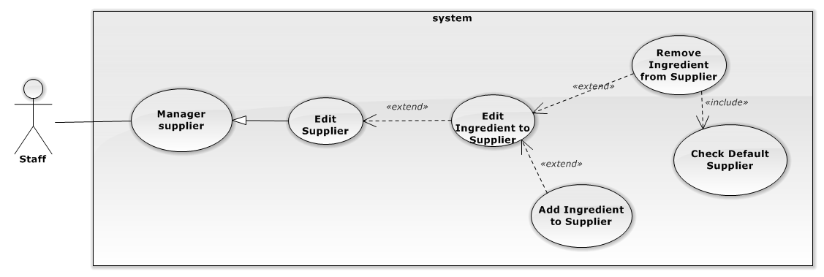

Figure 4-4: Edit supplier Use case

| **USE CASE SPECIFICATION** | | | |
| --- | --- | --- | --- |
| **Use-case No.** |  | **Use-case Version** |  |
| **Use-case Name** | Edit supplier | | |
| **Author** | Phạm văn Duy | | |
| **Date** |  | **Priority** |  |
| **Actor:**  Staff  **Summary:**  Staff edit supplier  **Goal:**  The purpose of Edit supplier use case is allowed Staff to request for edit supplier in the system.  **Triggers:**  Staff wants to create new supplier  Staff clicks on “Nhà cung cấp” menu on menu bar and then click on the D:\Deletebtn.png button in the table of supplier. Modify information and then click “Lưu” button.  **Preconditions:**  User must logged-in as Staff-role.  **Post Conditions:**  **Success:**   * The Staff is presented with an success message on screen.   **Failure:**   * The Staff is presented with an error message on screen.   **Main Success Scenario:**   |  |  | | --- | --- | | Actor Actions | System Response | | 1. Staff click on the “Nhà cung cấp” menu on menu bar.     3. Staff clicks on the D:\Deletebtn.png button in the table of supplier.  5. Staff fills suplier information form.  7. Staff clicks on “Lưu” button.  9. Staff clicks on the D:\Deletebtn.pngbutton in the table of supplier.  11. Staff clicks on the tag “Chọn nguyên liệu”.  13. Staff drag ingredient from the left container to the the right container .  [Alternative 1][ Alternative 2]  15. Staff press the “Lưu” button.  [Alternative 3] | 1. Redirect to “Nhà cung cấp” page   4. The pop up “Thông tin nhà cung cấp” is displayed on screen.  6. Supplier information form includes:   * “Tên” [Name of supplier, Textbox, max length: 100, require] * “Số điện thoại”[Phone number, Textbox, regular expression: (^[0-9]{10,11}$), require] * “Danh mục”[Category of Supplier, Dropdown list include all category available] * “Địa chỉ”[Address, Textbox, The under is google map for staff choose address] * “Lưu” button.     [Exception 1] [Exception 2]  [Exception 3] [Exception 4]  [Exception 5] [Exception 6]  [Exception 7] [Exception 8]  [Exception 9]  8. Message display ”Cập nhập nhà cung cấp thành công!”  10. The pop up “Thông tin nhà cung cấp” is displayed on screen.  12. The view ingredients is displayed include:   * The view contains all ingredient in the left. * The Selected Ingredient Container in the right.   14. The ingredient in the left container s removed to the right container.  [Exception 8] [Exception 9]  [Exception 10]  15. The pop up is closed and the message is displayed “Cập nhập thành công!” | |  |  |   **Alternative Scenario:**   |  |  | | --- | --- | | Actor Actions | System Response | | [Alternative 1]   1. Staff press the “X” button of ingredient in the right container andthen click “OK” button.   3. Staff press the “Lưu” button.  [Alternative 2]   1. Press the “X” button of ingredient in the right container, then press “Cancle” button in the message box. | 1. The pop up is displayed included:  * List of all other supplier. * “Lưu” button.   2. The message box is closed. |     **Exceptions:**   |  |  | | --- | --- | | Actor Actions | System Response | | [Exception 1]  1. Supplier’s “Tên” is missing.  [Exception 2]  1. Supplier’s “Name” is exist.  [Exception 3]  1. The length of Supplier’s “Name” is out of range.  [Exception 4]  1. Supplier’s “Số điện thoại” is missing.  [Exception 5]   1. 1. Supplier’s “Số điện thoại” is not in correct format.   [Exception 6]  1. Supplier’s “Địa chỉ” is missing.  [Exception 7]  1. Supplier’s “Địa chỉ” is not correct.  [Exception 8]  1. System cannot Edit supplier.  [Exception 9]  1. System cannot load supplier.  [Exception 10]  1. The right containter is empty. | 2. Shows error “Không được để trống!” on textbox.  2. Shows error “Tên này đã tồn tại ” under textbox.  2. Shows error “Tên quá dài (hơn 250 ký tự) on screen.  2. Shows error “Không được để trống!” on textbox.  2.Shows error “Số điện thoại không đúng” to customer.  2. Shows error “Không được để trống!” on textbox.  2. Shows error “Địa chỉ không đúng!” on textbox.  2. Shows error ”Xảy ra lỗi, xin hay thử lại.!” on screen.    2. Show message “Hệ thống không thể kết nối với cơ sở dữ liệu.”  2. Show error “Cần có ít nhất 1 nguyên liệu” on screen. |   **Relationships:**   * Edit ingredient of supplier   **Business Rules:**  N/A | | | |
|  | | | |

##### 4.2.1.2.3 Delete Supplier

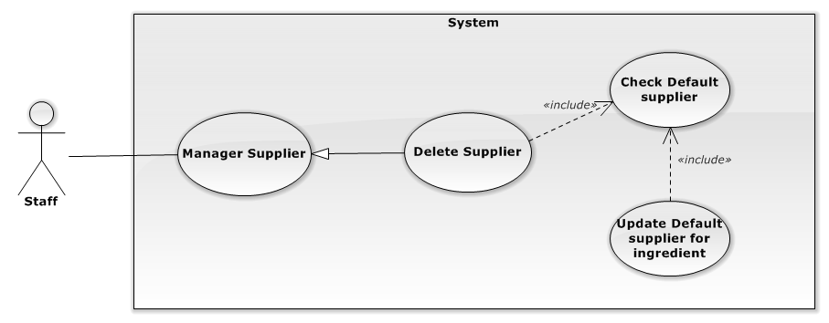

| **USE CASE SPECIFICATION** | | | |
| --- | --- | --- | --- |
| **Use-case No.** |  | **Use-case Version** |  |
| **Use-case Name** | Delete Supplier | | |
| **Author** | Phạm văn Duy | | |
| **Date** |  | **Priority** |  |
| **Actor:**  Staff  **Summary:**  Staff Delete supplier  **Goal:**  The purpose of delete supplier use case is allowed Staff to request for delete supplier in the system.  **Triggers:**  Staff wants to delete supplier  Staff clicks on “Nhà cung cấp” menu on menu bar and then click on the D:\Editbutton.png button of supplier.  **Preconditions:**  User must logged-in as Staff-role.  **Post Conditions:**  **Success:**   * The Staff is presented with an success message on screen.   **Failure:**   * The Staff is presented with an error message on screen.   **Main Success Scenario:**   |  |  | | --- | --- | | Actor Actions | System Response | | 1. Staff click on the “Nhà cung cấp” menu on menu bar.    3. Staff clicks con the D:\Editbutton.png button of supplier.  5. Staff click “OK” button  [Alternative 1]  7. Staff choose supplier and click “Lưu” button. | 2. Redirect to “Nhà cung cấp” page  4. System check selected supplier is being default of any ingredient?   * If result is false: System will set IsActive to false. * If result is true: System will display confirm box.   [Exception 1]  6. The pop up window is displayed included:   * List of ingredient which have deafult supplier is seleted supplier. * List of the other supplier * “Lưu” button.   [Exception 1] [Exception 2]  [Exception 3]  8. The message is displayed :”Xóa thành công”. | |  |  |   **Alternative Scenario:**   |  |  | | --- | --- | | Actor Actions | System Response | | [Alternative 1]  1. Staff click “Cancel” button. | 2. The pop up windowis closed. |     **Exceptions:**   |  |  | | --- | --- | | Actor Actions | System Response | | [Exception 1]  1 . System cannot load.  [Exception 2]  1. System cannot delete supplier.  [Exception 3]  1. System cannot save supplier default of ingredient. | 2. Show message “Hệ thống không thể kết nối với cơ sở dữ liệu.”  2. Show message “Xảy ra lỗi, xin hãy thử lại!.”  2. Show message “Xảy ra lỗi, xin hãy thử lại!.” |   **Relationships:**  N/A  **Business Rules:**  N/A | | | |
|  | | | |

##### 4.2.1.2.4 Restore Supplier

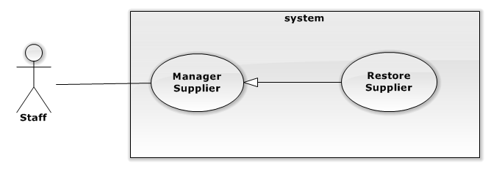

| **USE CASE SPECIFICATION** | | | |
| --- | --- | --- | --- |
| **Use-case No.** |  | **Use-case Version** |  |
| **Use-case Name** | Restore Supplier | | |
| **Author** | Phạm văn Duy | | |
| **Date** |  | **Priority** |  |
| **Actor:**  Staff  **Summary:**  Staff restore supplier  **Goal:**  The purpose of restore supplier use case is allowed Staff to request for restore supplier after delete in the system.  **Triggers:**  Staff wants to restore supplier  Staff clicks on “Nhà cung cấp” menu on menu bar and then click on the D:\restorebtn.png button of supplier.  **Preconditions:**  User must logged-in as Staff-role.  **Post Conditions:**  **Success:**   * The Staff is presented with an success message on screen.   **Failure:**   * The Staff is presented with an error message on screen.   **Main Success Scenario:**   |  |  | | --- | --- | | Actor Actions | System Response | | 1. Staff click on the “Nhà cung cấp” menu on menu bar.    3. Staff clicks on the D:\restorebtn.png button of supplier.  5. Staff click “OK” button  [Alternative 1] | 2. Redirect to “Nhà cung cấp” page    4. The confirm box is show.  6. System will set IsActive to False and reload page.  [Exception 1] [Exception 2] | |  |  |   **Alternative Scenario:**   |  |  | | --- | --- | | Actor Actions | System Response | | [Alternative 1]  1. Staff click “Cancel” button. | 2. The pop up windowis closed. |     **Exceptions:**   |  |  | | --- | --- | | Actor Actions | System Response | | [Exception 1]  1 . System cannot load.  [Exception 2]  1. System cannot restore supplier. | 2. Show message “Hệ thống không thể kết nối với cơ sở dữ liệu.”  2. Show message “Xảy ra lỗi, xin hãy thử lại!.” |   **Relationships:**  N/A  **Business Rules:**  N/A | | | |
|  | | | |

##### 4.2.1.2.5 Show Supplier

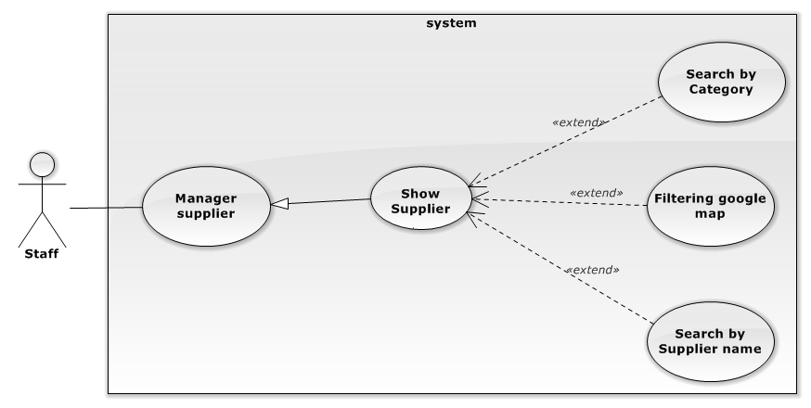

| **USE CASE SPECIFICATION** | | | |
| --- | --- | --- | --- |
| **Use-case No.** |  | **Use-case Version** |  |
| **Use-case Name** | Show Supplier | | |
| **Author** | Phạm văn Duy | | |
| **Date** |  | **Priority** |  |
| **Actor:**  Staff  **Summary:**  Staff show supplier  **Goal:**  The purpose of show supplier use case is allowed Staff to request for viewing all supplier on screen in the system.  **Triggers:**  Staff wants to show supplier  Staff clicks on “Nhà cung cấp” menu on menu bar.  **Preconditions:**  User must logged-in as Staff-role.  **Post Conditions:**  **Success:**   * Supplier are shown in table of “Quản lí nhà cung cấp” screen match with search conditions.   **Failure:**   * The Staff is presented with an error message on screen.   **Main Success Scenario:**   |  |  | | --- | --- | | Actor Actions | System Response | | 1. Staff click on the “Nhà cung cấp” menu on menu bar.    3. Staff choose filter oftions or type keyword for search.    5. Staff filter on google map by tick into category checkbox. | 2. Redirect to “Nhà cung cấp” page include:   * Search section: : includes   “Tìm kiếm”[Keyword: TextBox, default is Empty]   * Two filter for Supplier Category[Supplier Category Filter: Drop-down list, default is “Tất cả danh mục”] and sorting[Sort Filter: Drop-down list, default is “Tên: A đến Z”]. * Paging control[Paging: list of Action Link, default is set at page 1]. * Supplier Panel section: includes result suppliers for search conditions. * Goole map[Default marker is empty] * Table contain all category to filter on google map.     4. Supplier panel display list of suitable suppliers for filter options.  [Exception 1]  6. Google show all markers of suppliers which have category is selected category.  [Exception 2] | |  |  |   **Alternative Scenario:**   |  |  | | --- | --- | | Actor Actions | System Response | | N/A | N/A |     **Exceptions:**   |  |  | | --- | --- | | Actor Actions | System Response | | [Exception 1]  1 . System cannot load.  [Exception 2]  1. System can not load marker ofsupplier. | 2. Show message “Hệ thống không thể kết nối với cơ sở dữ liệu.”  2. Show message “Không tìm thấy đia điểm!.” |   **Relationships:**  N/A  **Business Rules:**  N/A | | | |
|  | | | |

##### 4.2.1.3 Manage Ingredient

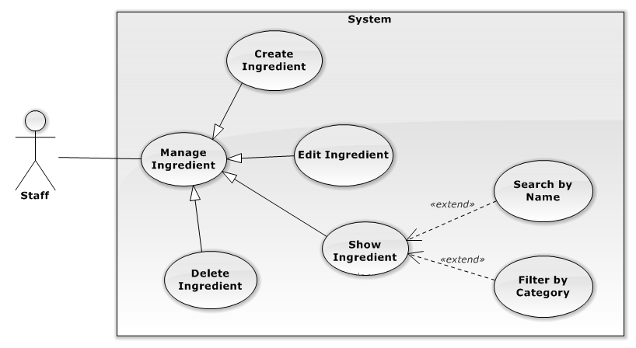

##### 4.2.1.3.1 Create Ingredient

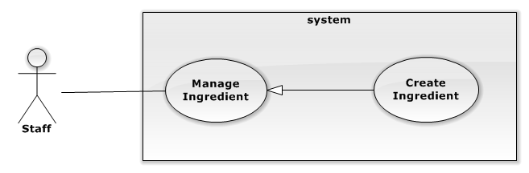

| **USE CASE SPECIFICATION** | | | |
| --- | --- | --- | --- |
| **Use-case No.** |  | **Use-case Version** |  |
| **Use-case Name** | Create new ingredient | | |
| **Author** | Phạm văn Duy | | |
| **Date** |  | **Priority** |  |
| **Actor:**  Staff  **Summary:**  Staff creates new ingredient.  **Goal:**  The purpose of Create new ingredient use case is allowed Staff to request for creating new ingredient in the system.  **Triggers:**  Staff wants to create new ingredient  Staff clicks on “Nguyên liệu” menu on menu bar and then click on the “Thêm mới” button.  **Preconditions:**  User must logged-in as Staff-role.  **Post Conditions:**  **Success:**   * The Staff is presented with an success message on screen.   **Failure:**   * The Staff is presented with an error message on screen.   **Main Success Scenario:**   |  |  | | --- | --- | | Actor Actions | System Response | | 1. Staff click on the “Nguyên liệu” menu on menu bar.     3. Staff clicks on the “Thêm mới” button.  7. Staff fills ingredient information form and clicks on “Thêm” button. | 1. Redirect to “Nhà cung cấp” page   4. The pop up “Thêm nguyên liệu” is displayed on screen. Ingredient information form includes:   * “Tên” [Name of ingredient , Textbox, max length: 100, require] * “Danh mục”[Category of Supplier, Dropdown list include all category available] * “Nhà cung cấp mặc định” [Supplier default of ingredient] * “Hình ảnh”[Image of ingredient, File (Default file is empty)]. * “Truy nguyên” [Tracibility of ingredient(Default if false)] * “Thêm” button.     [Exception 1] [Exception 2]  [Exception 3] [Exception 4]  [Exception 5]  8. The pop up is closed and the message is displayed “Thêm nguyên liệu thành công”. | |  |  |   **Alternative Scenario:**   |  |  | | --- | --- | | Actor Actions | System Response | | N/A | N/A |     **Exceptions:**   |  |  | | --- | --- | | Actor Actions | System Response | | [Exception 1]  1. Ingredient’s “Tên” is missing.  [Exception 2]  1. The length of Supplier’s “Tên” is out of range.  [Exception 3]  1. Ingredient’s “Tên” is exist.    [Exception 4]  1. System cannot create ingredient.  [Exception 5]  1. System fails to load ingredient. | 2. Shows error “Không được để trống!” on textbox.   1. Shows error “Tên quá dài (hơn 100 ký tự) under “Tên” texbox.   2. Shows error “Tên này đã tồn tại!” under “Tên” textbox.  2. Shows error ”Xảy ra lỗi, xin hãy thử lại.!” on screen.    2. Show message “Hệ thống không thể kết nối với cơ sở dữ liệu.” |   **Relationships:**  N/A  **Business Rules:**   * Max character of “Tên” is 100 . * Name is not identical. | | | |
|  | | | |

##### 4.2.1.3.2Edit Ingredient

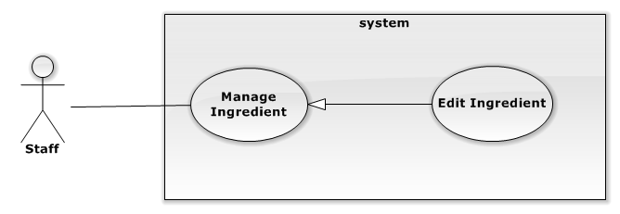

| **USE CASE SPECIFICATION** | | | |
| --- | --- | --- | --- |
| **Use-case No.** |  | **Use-case Version** |  |
| **Use-case Name** | Edit ingredient | | |
| **Author** | Phạm văn Duy | | |
| **Date** |  | **Priority** |  |
| **Actor:**  Staff  **Summary:**  Staff edits new ingredient.  **Goal:**  The purpose of edits ingredient use case is allowed Staff to request for editing ingredient in the system.  **Triggers:**  Staff wants to edits ingredient  Staff clicks on “Nguyên liệu” menu on menu bar and then click on the ingredient.  **Preconditions:**  User must logged-in as Staff-role.  **Post Conditions:**  **Success:**   * The Staff is presented with an success message on screen.   **Failure:**   * The Staff is presented with an error message on screen.   **Main Success Scenario:**   |  |  | | --- | --- | | Actor Actions | System Response | | 1. Staff click on the “Nguyên liệu” menu on menu bar.     3. Staff clicks on the Ingredient.  7. Staff edit ingredient information form and clicks on “Thêm” button. | 1. Redirect to “Nhà cung cấp” page   4. The pop up “Thông tin nguyên liệu” is displayed on screen. Ingredient information form includes:   * “Tên” [Name of ingredient , Textbox, max length: 100, require] * “Danh mục”[Category of Supplier, Dropdown list include all category available] * “Nhà cung cấp mặc định” [Supplier default of ingredient] * “Hình ảnh”[Image of ingredient, File (Default file is empty)]. * “Truy nguyên” [Tracibility of ingredient(Default if false)] * “Thêm” button. * “Xóa” button.     [Exception 1] [Exception 2]  [Exception 3] [Exception 4]  [Exception 5]  8. The pop up is closed and the message is displayed “Thêm nguyên liệu thành công”. | |  |  |   **Alternative Scenario:**   |  |  | | --- | --- | | Actor Actions | System Response | | N/A | N/A |     **Exceptions:**   |  |  | | --- | --- | | Actor Actions | System Response | | [Exception 1]  1. Ingredient’s “Tên” is missing.  [Exception 2]  1. The length of Supplier’s “Tên” is out of range.  [Exception 3]  1. Ingredient’s “Tên” is exist.    [Exception 4]  1. System cannot create ingredient.  [Exception 5]  1. System fails to load ingredient. | 2. Shows error “Không được để trống!” on textbox.   1. Shows error “Tên quá dài (hơn 100 ký tự) under “Tên” texbox.   2. Shows error “Tên này đã tồn tại!” under “Tên” textbox.  2. Shows error ”Xảy ra lỗi, xin hãy thử lại.!” on screen.    2. Show message “Hệ thống không thể kết nối với cơ sở dữ liệu.” |   **Relationships:**  N/A  **Business Rules:**  N/A | | | |
|  | | | |

##### 4.2.1.3.3 Delete ingredient

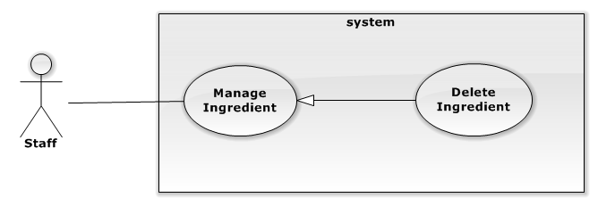

| **USE CASE SPECIFICATION** | | | |
| --- | --- | --- | --- |
| **Use-case No.** |  | **Use-case Version** |  |
| **Use-case Name** | Delete ingredient | | |
| **Author** | Phạm văn Duy | | |
| **Date** |  | **Priority** |  |
| **Actor:**  Staff  **Summary:**  Staff delete supplier  **Goal:**  The purpose of delete supplier use case is allowed Staff to request for delete ingredient in the system.  **Triggers:**  Staff wants to delete supplier  Staff clicks on “Nhà cung cấp” menu on menu bar and then click on the ingredient and click “Xóa” button on pop up window.  **Preconditions:**  User must logged-in as Staff-role.  **Post Conditions:**  **Success:**   * The Staff is presented with an success message on screen.   **Failure:**   * The Staff is presented with an error message on screen.   **Main Success Scenario:**   |  |  | | --- | --- | | Actor Actions | System Response | | 1. Staff click on the “Nguyên liệu” menu on menu bar.    3. Staff clicks on the Ingredient.  5. Staff click “Xóa” button   1. Staff click ”OK” button   [Alternative 1] | 2. Redirect to “Quản lí nguyên liệu” page    4. The pop up “Thông tin nguyên liệu” is displayed on screen. Ingredient information form includes:   * “Tên” [Name of ingredient , Textbox, max length: 100, require] * “Danh mục”[Category of Supplier, Dropdown list include all category available] * “Nhà cung cấp mặc định” [Supplier default of ingredient] * “Hình ảnh”[Image of ingredient, File (Default file is empty)]. * “Truy nguyên” [Tracibility of ingredient(Default if false)] * “Thêm” button. * “Xóa” button.   6. The confirm box will be displayed.  8. Show message “Xóa thành công!.”  [Exception 1] [Exception 2] | |  |  |   **Alternative Scenario:**   |  |  | | --- | --- | | Actor Actions | System Response | | [Alternative 1]  1. Staff click “Cancel” button. | 2. The pop up windowis closed. |     **Exceptions:**   |  |  | | --- | --- | | Actor Actions | System Response | | [Exception 1]  1 . System cannot load.  [Exception 2]  1. System cannot restore supplier. | 2. Show message “Hệ thống không thể kết nối với cơ sở dữ liệu.”  2. Show message “Xảy ra lỗi, xin hãy thử lại!.” |   **Relationships:**  N/A  **Business Rules:**  N/A | | | |
|  | | | |

##### 4.2.1.3.4 Show ingredient

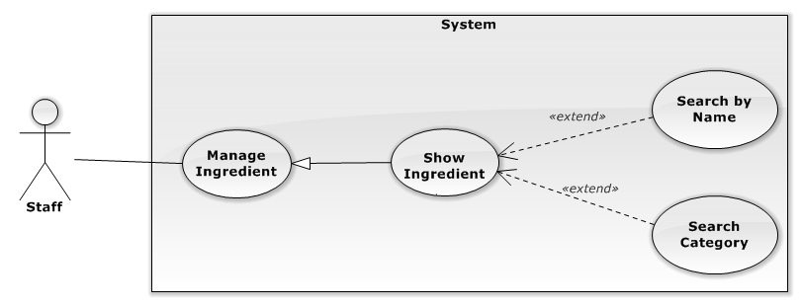

| **USE CASE SPECIFICATION** | | | |
| --- | --- | --- | --- |
| **Use-case No.** |  | **Use-case Version** |  |
| **Use-case Name** | Show ingredient | | |
| **Author** | Phạm văn Duy | | |
| **Date** |  | **Priority** |  |
| **Actor:**  Staff  **Summary:**  Staff show ingredient  **Goal:**  The purpose of show ingredient use case is allowed Staff to request for viewing all ingredient on screen in the system.  **Triggers:**  Staff wants to show ingredient  Staff clicks on “Nguyên liệu” menu on menu bar.  **Preconditions:**  User must logged-in as Staff-role.  **Post Conditions:**  **Success:**   * Ingredient are shown in table of “Quản lí nguyên liệu” screen match with search conditions.   **Failure:**   * The Staff is presented with an error message on screen.   **Main Success Scenario:**   |  |  | | --- | --- | | Actor Actions | System Response | | 1. Staff click on the “Nguyên liệu” menu on menu bar.    3. Staff choose filter oftions or type keyword for search. | 2. Redirect to “Quản lí nguyên liệu” page include:   * Search section: : includes   “Tìm kiếm”[Keyword: TextBox, default is Empty]   * Two filter for Supplier Category[Supplier Category Filter: Drop-down list, default is “Tất cả danh mục”] and sorting[Sort Filter: Drop-down list, default is “Tên: A đến Z”]. * Paging control[Paging: list of Action Link, default is set at page 1]. * Supplier Panel section: includes result ingredients for search conditions.     4. Ingredient panel display list of suitable ingredients for filter options.  [Exception 1] | |  |  |   **Alternative Scenario:**   |  |  | | --- | --- | | Actor Actions | System Response | | N/A | N/A |     **Exceptions:**   |  |  | | --- | --- | | Actor Actions | System Response | | [Exception 1]  1 . System cannot load. | 2. Show message “Hệ thống không thể kết nối với cơ sở dữ liệu.” |   **Relationships:**  N/A  **Business Rules:**  N/A | | | |
|  | | | |

##### 4.2.1.4 Manage User

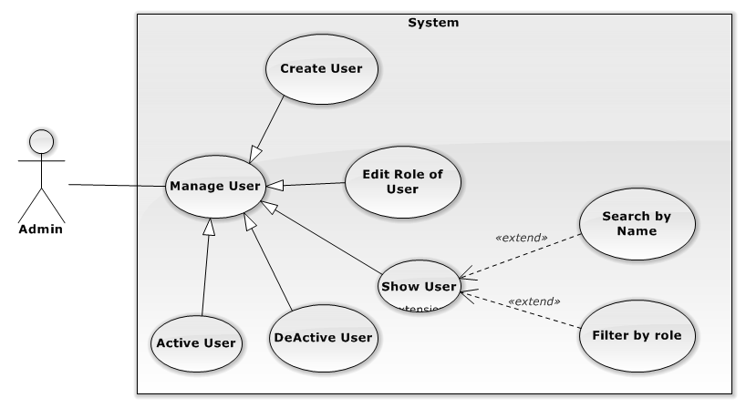

##### 4.2.1.4.1 Create user

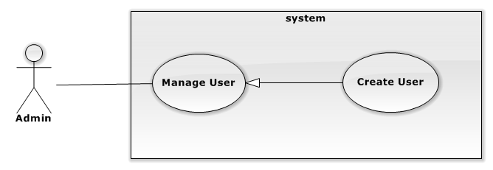

| **USE CASE SPECIFICATION** | | | |
| --- | --- | --- | --- |
| **Use-case No.** |  | **Use-case Version** |  |
| **Use-case Name** | Create user | | |
| **Author** | Phạm văn Duy | | |
| **Date** |  | **Priority** |  |
| **Actor:**  Staff  **Summary:**  Staff creates user.  **Goal:**  The purpose of Create user use case is allowed Staff to request for creating user in the system.  **Triggers:**  Staff wants to create user.  Staff clicks on “Nhân viên” menu on menu bar and then click on the “Thêm mới” button.  **Preconditions:**  User must logged-in as Staff-role.  **Post Conditions:**  **Success:**   * The Staff is presented with an success message on screen.   **Failure:**   * The Staff is presented with an error message on screen.   **Main Success Scenario:**   |  |  | | --- | --- | | Actor Actions | System Response | | 1. Staff click on the “Nguyên liệu” menu on menu bar.     3. Staff clicks on the “Thêm mới” button.  7. Staff fills user information form and clicks on “Thêm” button. | 1. Redirect to “Nhà cung cấp” page   4. The pop up “Thêm Tài khoản” is displayed on screen. user information form includes:   * “Tên đăng nhập” [Username of user, Textbox, maxlength: 50, require]. * “Mật khẩu” [Password of user,Textbox]. * “Xác nhận Mật khẩu” [Password of user,Textbox]. * “Tên đầy đủ” [Name of user , Textbox, max length: 100, require]. * “Email” [Email of user, Textbox, regular expression: ^ ([a-zA-Z0-9_\.\-])+\@ (([a-zA-Z0-9\-]) +\.) +([a-zA-Z0-9] {2,4})+$] * “Số điện thoại” [Phone number: Numeric Textbox, regular expression: ^[0-9]{8,11}$]. * “Ngày sinh” [Birthday, regular expression: ^([0-9]{4})-([0-9]{2})-([0-9]{2})$]. * “Vai trò”[Role of user, Dropdown list include all role, default role is empty] * “Địa chỉ”[Address,Texbox)]. * “Giới tính” [Gender of user (Default is Name)] * “Thêm” button.     [Exception 1] [Exception 2] [Exception 5]  [Exception 3] [Exception 4] [Exception 5]  [Exception 6] [Exception 7] [Exception 8]  [Exception 9] [Exception 10][Exception 11]  [Exception 12][Exception 13][Exception 14]  [Exception 15][Exception 16][Exception 17]  [Exception 18]  8. The pop up is closed and the message is displayed “Thêm Tài khoản thành công”. | |  |  |   **Alternative Scenario:**   |  |  | | --- | --- | | Actor Actions | System Response | | N/A | N/A |     **Exceptions:**   |  |  | | --- | --- | | Actor Actions | System Response | | [Exception 1]  1. User “Tên đăng nhập” is missing.  [Exception 2]  1. The length of User’s “Tên đăng nhập” is out of range.  [Exception 3]  1. User’s “Tên đăng nhập” is exist.  [Exception 4]  1. User “Mật khẩu” is missing.  [Exception 5]  1. User “Xác nhận” is missing.  [Exception 6]  1. “Mật khẩu” don’t match with “Xác nhận mật khẩu”.  [Exception 7]  1. User “Tên đầy đủ” is missing.  [Exception 8]  1. The length of User’s “Tên đầy đủ” is out of range.  [Exception 9]  1. User “Email” is missing.  [Exception 10]  1. User “Email” is not correct format.  [Exception 11]  1. User “Số điện thoại” is missing.  [Exception 12]  1. User “Số điện thoại” is not correct format  [Exception 13]  1. User “Ngày sinh” is missing.  .  [Exception 14]  1. User “Ngày sinh” is not correct format  [Exception 15]  1. User “Vai trò” is missing.  [Exception 16]  1. User “Địa chỉ” is missing.  [Exception 17]  1. System cannot create user.  [Exception 18]  1. System fails to load user. | 2. Shows error “Không được để trống!” on textbox.  2. Shows error “Ký tự quá dài (hơn 100 ký tự) under “Tên” texbox.  2. Shows error “Tên này đã tồn tại!” under “Tên đăng nhập” textbox.  2. Shows error “Không được để trống!” on textbox.  2. Shows error “Không được để trống!” on textbox.  2. Shows error “Mật khẩu không trùng!” under “Xác nhận mật khẩu” textbox.  2. Shows error “Không được để trống!” on textbox.  2. Shows error “Ký tự quá dài (hơn 100 ký tự) under “Tên đầy đủ” texbox.  2. Shows error “Không được để trống!” on textbox.  2. Shows error “Email không hợp lệ!” on textbox.  2. Shows error “Không được để trống!” on textbox.  2. Shows error “Số điện thoại không hợp lệ!” on textbox.  2. Shows error “Không được để trống!” on textbox.  2. Shows error “Ngày sinh không hợp lệ!” on textbox.  2. Shows error “Không được để trống!” on textbox.  2. Shows error “Không được để trống!” on textbox.  2. Show message “Xảy ra lỗi, Xin hãy thử lại.”  2. Show message “Hệ thống không thể kết nối với cơ sở dữ liệu.” |   **Relationships:**  N/A  **Business Rules:**  N/A | | | |
|  | | | |

##### 4.2.1.4.2 Edit role of user

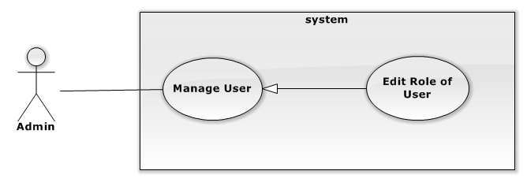

| **USE CASE SPECIFICATION** | | | |
| --- | --- | --- | --- |
| **Use-case No.** |  | **Use-case Version** |  |
| **Use-case Name** | Edit supplier | | |
| **Author** | Phạm văn Duy | | |
| **Date** |  | **Priority** |  |
| **Actor:**  Staff  **Summary:**  Staff edit role of user  **Goal:**  The purpose of Edit role of user use case is allowed Staff to request for edit role of user in the system.  **Triggers:**  Staff wants to edit role of user  Staff clicks on “Nhân viên” menu on menu bar and then click on the D:\Deletebtn.png button in the table of user . Modify role and then click “Lưu” button.  **Preconditions:**  User must logged-in as Staff-role.  **Post Conditions:**  **Success:**   * The Staff is presented with an success message on screen.   **Failure:**   * The Staff is presented with an error message on screen.   **Main Success Scenario:**   |  |  | | --- | --- | | Actor Actions | System Response | | 1. Staff click on the “Nhân viên” menu on menu bar.     3. Staff clicks on the D:\Deletebtn.png button in the table of supplier.  6. Staff modify rolde of user information form and clicks on “Lưu” button. | 1. Redirect to “Quản lí nhân viên” page   5. The pop up “Thông tin tài khoản” is displayed on screen. User information form includes:   * “Vai trò”[Role of user, Dropdown list include all role, default role is empty] * “Lưu” button.     [Exception 1] [Exception 2]  [Exception 3]  7. Message display ”Cập nhập tài khoản thành công!” | |  |  |   **Alternative Scenario:**   |  |  | | --- | --- | | Actor Actions | System Response | | [Alternative 1]  N/A | N/A |     **Exceptions:**   |  |  | | --- | --- | | Actor Actions | System Response | | [Exception 1]  1. User’s “Vai trò” is missing.  [Exception 2]  1. System cannot save user.  [Exception 3]  1. System fails to load user. | 2. Shows error “Không được để trống!” on textbox.  2. Show message “Xảy ra lỗi, Xin hãy thử lại.”  2. Show message “Hệ thống không thể kết nối với cơ sở dữ liệu.” |   **Relationships:**  N/A  **Business Rules:**  N/A | | | |
|  | | | |

##### 4.2.1.4.3 Delete user

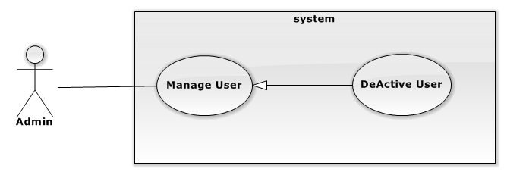

| **USE CASE SPECIFICATION** | | | |
| --- | --- | --- | --- |
| **Use-case No.** |  | **Use-case Version** |  |
| **Use-case Name** | Deactive user | | |
| **Author** | Phạm văn Duy | | |
| **Date** |  | **Priority** |  |
| **Actor:**  Staff  **Summary:**  Staff deactive user  **Goal:**  The purpose of deactive user use case is allowed Staff to request for deactive user in the system.  **Triggers:**  Staff wants to deactive user.  Staff clicks on “Nhân viên” menu on menu bar and then click on the D:\Editbutton.png button of user.  **Preconditions:**  User must logged-in as Staff-role.  **Post Conditions:**  **Success:**   * The Staff is presented with an success message on screen.   **Failure:**   * The Staff is presented with an error message on screen.   **Main Success Scenario:**   |  |  | | --- | --- | | Actor Actions | System Response | | 1. Staff click on the “Nhân viên” menu on menu bar.    3. Staff clicks con the D:\Editbutton.png button of user.  5. Staff click “OK” button  [Alternative 1] | 2. Redirect to “Quản lí người dùng” page  4. The confirm box will be displayed.  [Exception 1] [Exception 2]  8. The message is displayed :”Xóa thành công”. | |  |  |   **Alternative Scenario:**   |  |  | | --- | --- | | Actor Actions | System Response | | [Alternative 1]  1. Staff click “Cancel” button. | 2. The pop up windowis closed. |     **Exceptions:**   |  |  | | --- | --- | | Actor Actions | System Response | | [Exception 1]  1 . System cannot load.  [Exception 2]  1. System cannot delete user. | 2. Show message “Hệ thống không thể kết nối với cơ sở dữ liệu.”  2. Show message “Xảy ra lỗi, xin hãy thử lại!.” |   **Relationships:**  N/A  **Business Rules:**  N/A | | | |
|  | | | |

##### 4.2.1.4.3 Active user

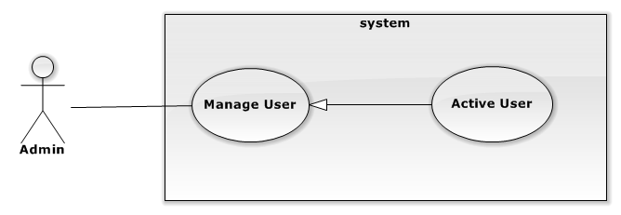

| **USE CASE SPECIFICATION** | | | |
| --- | --- | --- | --- |
| **Use-case No.** |  | **Use-case Version** |  |
| **Use-case Name** | Restore user | | |
| **Author** | Phạm văn Duy | | |
| **Date** |  | **Priority** |  |
| **Actor:**  Staff  **Summary:**  Staff restore user.  **Goal:**  The purpose of restore user use case is allowed Staff to request for restore user in the system.  **Triggers:**  Staff wants to restore user.  Staff clicks on “Nhân viên” menu on menu bar and then click on the D:\restorebtn.png button of user.  **Preconditions:**  User must logged-in as Staff-role.  **Post Conditions:**  **Success:**   * The Staff is presented with an success message on screen.   **Failure:**   * The Staff is presented with an error message on screen.   **Main Success Scenario:**   |  |  | | --- | --- | | Actor Actions | System Response | | 1. Staff click on the “Nhân viên” menu on menu bar.    3. Staff clicks con the D:\restorebtn.png button of user.  5. Staff click “OK” button  [Alternative 1] | 2. Redirect to “Quản lí người dùng” page  4. The confirm box will be displayed.  [Exception 1] [Exception 2]  8. The message is displayed :”Khôi phục thành công”. | |  |  |   **Alternative Scenario:**   |  |  | | --- | --- | | Actor Actions | System Response | | [Alternative 1]  1. Staff clic “Cancel” button. | 2. The pop up windowis closed. |     **Exceptions:**   |  |  | | --- | --- | | Actor Actions | System Response | | [Exception 1]  1 . System cannot load.  [Exception 2]  1. System cannot restore user. | 2. Show message “Hệ thống không thể kết nối với cơ sở dữ liệu.”  2. Show message “Xảy ra lỗi, xin hãy thử lại!.” |   **Relationships:**  N/A  **Business Rules:**  N/A | | | |
|  | | | |

##### 4.2.1.4.3 Show user



| **USE CASE SPECIFICATION** | | | |
| --- | --- | --- | --- |
| **Use-case No.** |  | **Use-case Version** |  |
| **Use-case Name** | Show user | | |
| **Author** | Phạm văn Duy | | |
| **Date** |  | **Priority** |  |
| **Actor:**  Admin  **Summary:**  Admin  show user  **Goal:**  The purpose of show user use case is allowed Staff to request for viewing all user on screen in the system.  **Triggers:**  Admin wants to show user  Admin clicks on “Nhân viên” menu on menu bar.  **Preconditions:**  User must logged-in as Admin-role.  **Post Conditions:**  **Success:**   * User are shown in table of “Quản lí nguyên liệu” screen match with search conditions.   **Failure:**   * The Admin is presented with an error message on screen.   **Main Success Scenario:**   |  |  | | --- | --- | | Actor Actions | System Response | | 1. Staff click on the “Nhân viên” menu on menu bar.    3. Admin choose filter oftions or type keyword for search. | 2. Redirect to “Quản lí Người dùng” page include:   * Search section: : includes   “Tìm kiếm”[Keyword: TextBox, default is Empty]   * Two filter for User Role[User Role Filter: Drop-down list, default is “Tất cả role”] and sorting[Sort Filter: Drop-down list, default is “Tên: A đến Z”]. * Paging control[Paging: list of Action Link, default is set at page 1]. * User Panel section: includes result users for search conditions.     4. User panel display list of suitable user for filter options.  [Exception 1] | |  |  |   **Alternative Scenario:**   |  |  | | --- | --- | | Actor Actions | System Response | | N/A | N/A |     **Exceptions:**   |  |  | | --- | --- | | Actor Actions | System Response | | [Exception 1]  1 . System cannot load. | 2. Show message “Hệ thống không thể kết nối với cơ sở dữ liệu.” |   **Relationships:**  N/A  **Business Rules:**  N/A | | | |
|  | | | |

# User Interface Design

##### View Supplier

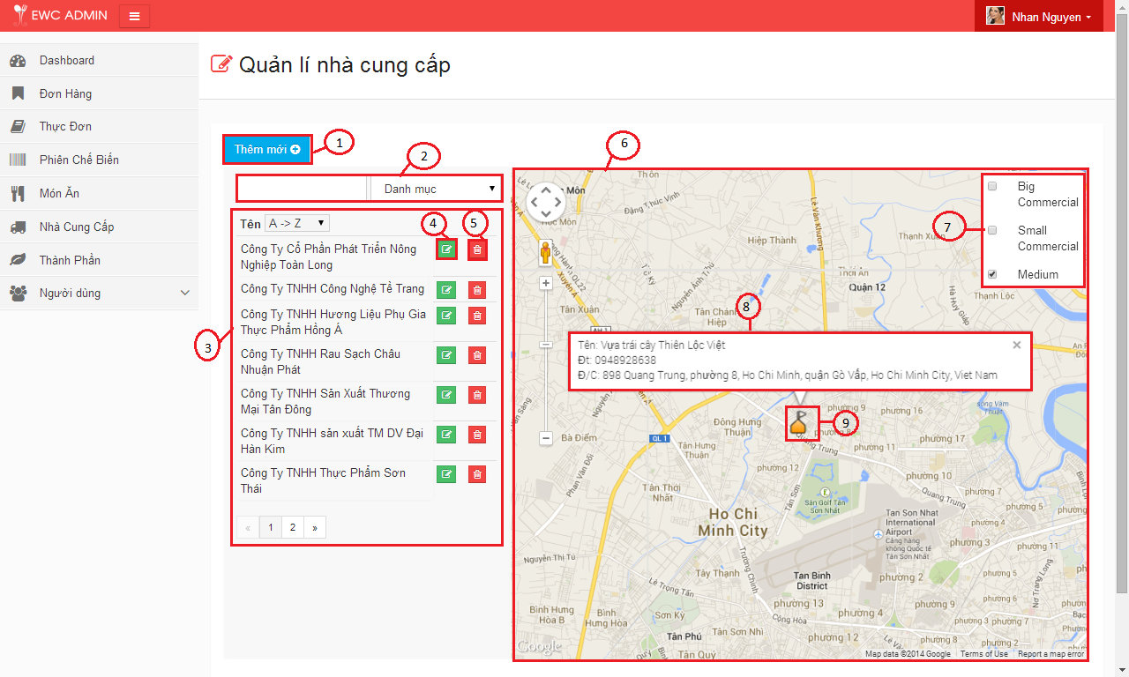

Figure 5.16: Supplier screen

|  |  |  |  |
| --- | --- | --- | --- |
| **No.** | **Name** | **Type** | **Description** |
| **1** | “Thêm mới” | Button | Display the pop up window to create new supplier |
| **2** | Search | Form | Search and sort supplier by name. Category. |
| **3** | List of suppliers | Table | Display all supplier. |
| **4** | “Sửa” | Button | Display the pop up window to edit supplier |
| **5** | “Xóa” | Button | Delete supplier |
| **6** | Google map | Google map | Display all market of supplier. |
| **7** | List of category | Table | Display all category. |
| **8** | Information of market | Textarea | Display information of supplier. |
| **9** | The coordinates of supplier | Marker | The coordinates of supplier. |

Table 5.16: Supplier screen decription.

##### 4.2.1.4.2 Create new supplier

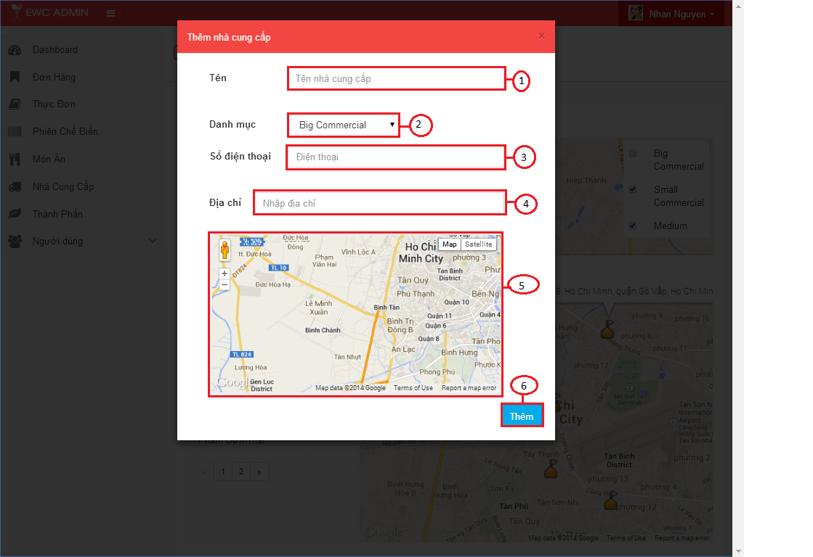

Figure 5.17: Create supplier screen

|  |  |  |  |
| --- | --- | --- | --- |
| **No.** | **Name** | **Type** | **Description** |
| **1** | “Tên” field | Textbox | Input name of supplier. |
| **2** | Category | DropdowList | List Category of supplier |
| **3** | “Số điện thoại” field | Textbox | Input Phone of supplier |
| **4** | “Địa chỉ” field | Textbox | Input Addres of supplier |
| **5** | Google map | Google map | Display marker to user choose. |
| **6** | “Thêm” button | Button | Create Supplier |

Table 5.16: Create supplier screen decription.

##### 4.2.1.4.3 Update information of supplier

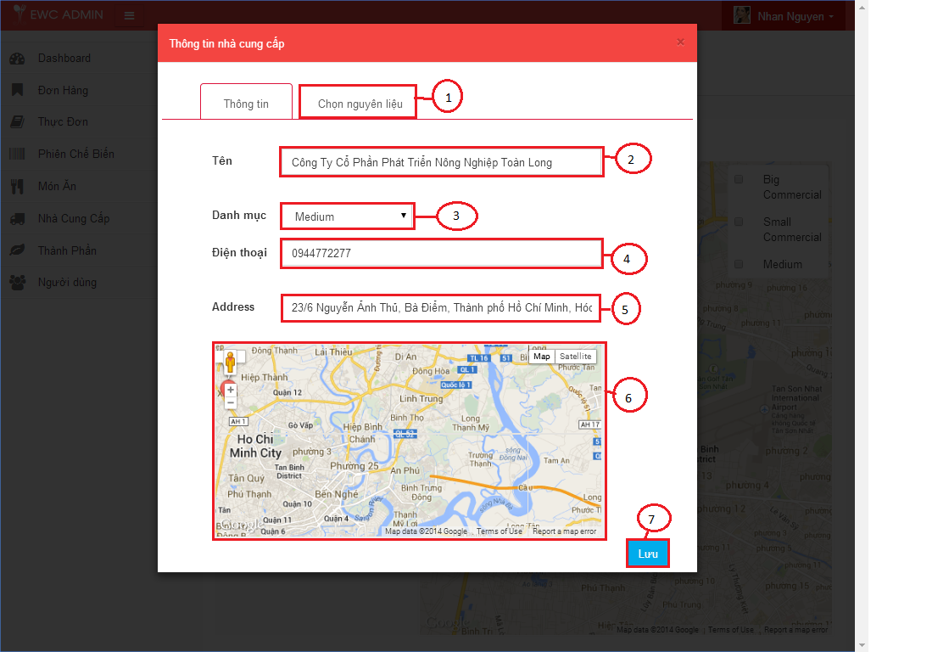

Figure 5.17: Update information of supplier screen

|  |  |  |  |
| --- | --- | --- | --- |
| **No.** | **Name** | **Type** | **Description** |
| **1** | “Chọn nguyên liệu” | Tab | Display all ingredient of supplier. |
| **2** | “Tên” field | Textbox | Input name of supplier. |
| **3** | Category | DropdowList | List Category of supplier |
| **4** | “Số điện thoại” field | Textbox | Input Phone of supplier |
| **5** | “Địa chỉ” field | Textbox | Input Addres of supplier |
| **6** | Google map | Google map | Display marker to user choose. |
| **7** | “Lưu” button | Button | Save supplier |

Table 5.16: Update Information supplier screen decription.

##### 4.2.1.4.4 Update ingredient of supplier

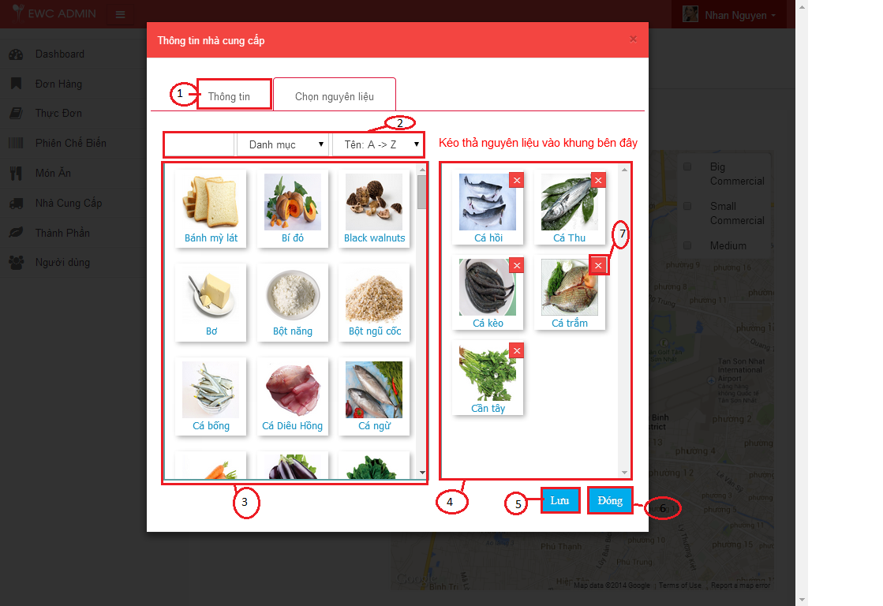

Figure 5.18: Update ingredient of supplier screen

|  |  |  |  |
| --- | --- | --- | --- |
| **No.** | **Name** | **Type** | **Description** |
| **1** | “Thông tin” tab | Tab | Display the information of supplier. |
| **2** | Search | Form | Search and sort ingredient by name, category. |
| **3** | List of ingredients not in supplier | Grid | Display all ingredients not in supplier. |
| **4** | List of ingredients in supplier | Grid | Display all igredient in supplier. |
| **5** | “Lưu” | Button | Save supplier. |
| **6** | “Đóng” | Button | Close pop up window. |
| **7** | ”Delete” | Button | Remove Ingredient of supplier. |

Table 5.16: Update ingredient of supplier screen decription.

##### 4.2.1.4.5 Update supplier default of ingredient

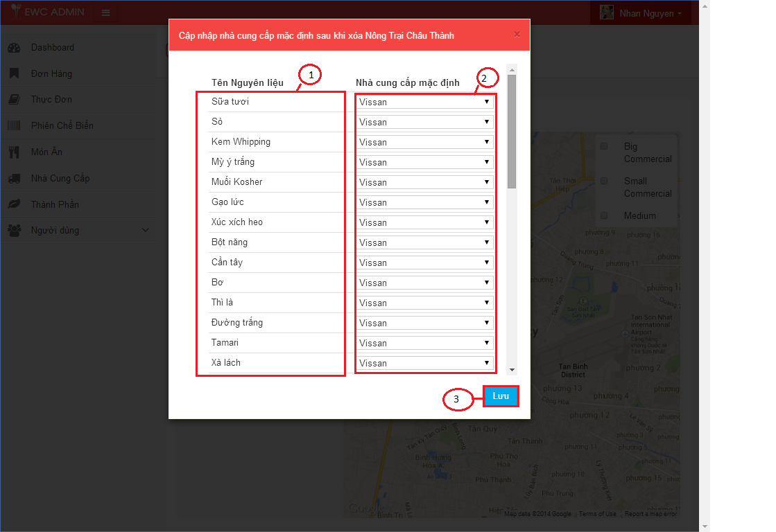

Figure 5.19: Update supplier default of ingredient screen

|  |  |  |  |
| --- | --- | --- | --- |
| **No.** | **Name** | **Type** | **Description** |
| **1** | List of inredient | Table | Display ingredients |
| **2** | List of supplier | Table | Display all suppliers. |
| **3** | “Lưu” | Button | Save. |

Table 5.16: Update supplier default of ingredient screen decription.

##### Manage ingredient

##### 4.2.1.5.1 View ingredient

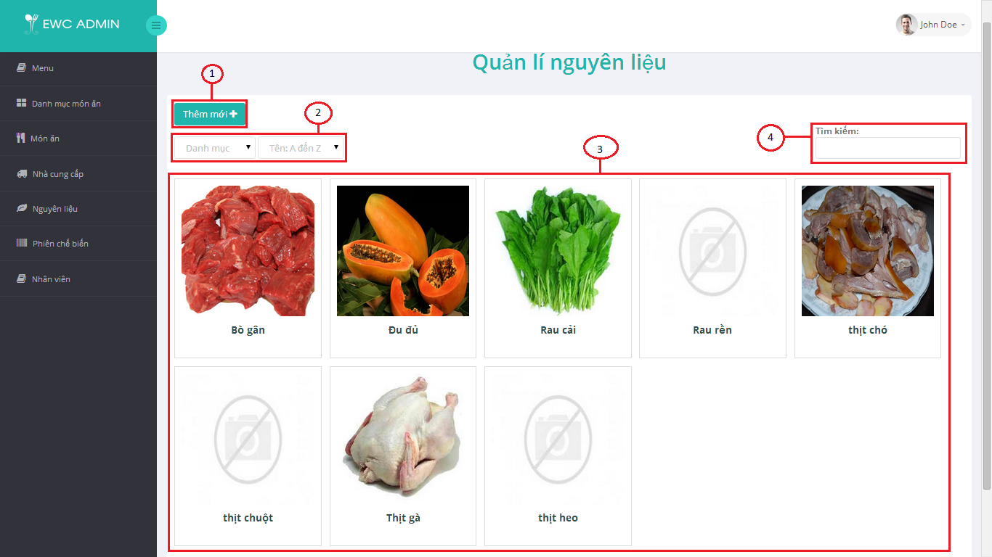

Figure 5.19 View ingredient screen

|  |  |  |  |
| --- | --- | --- | --- |
| **No.** | **Name** | **Type** | **Description** |
| **1** | “Thêm mơi” | Button | Display pop up window to create new ingredient. |
| **2** | Filter form | Form | Filter and sort ingredient category. |
| **3** | List of ingredients | Grid | Display all ingredients. |
| **4** | Search | Textbox | Search ingredient by name. |

Table 5.16: View ingredient screen decription.

##### 4.2.1.5.2 Create ingredient

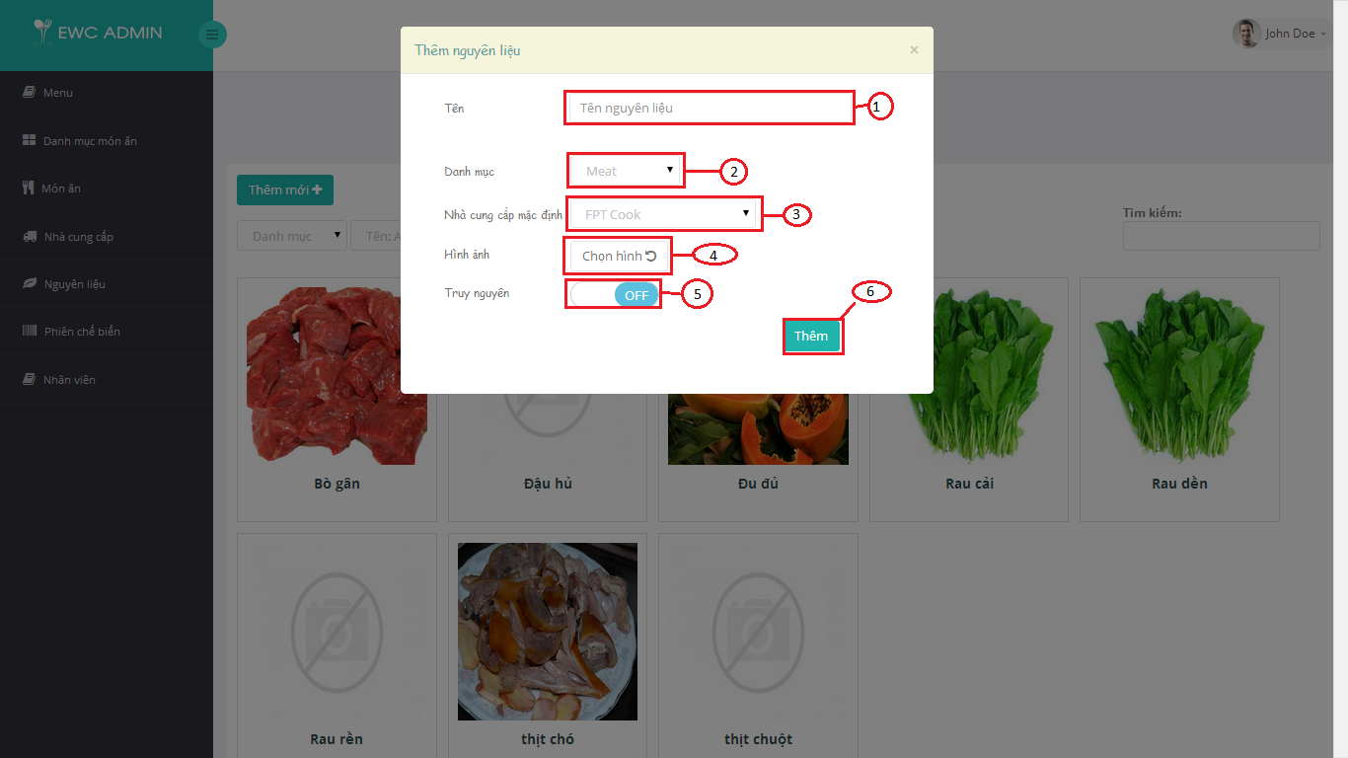

Figure 5.20 Create ingredient screen

|  |  |  |  |
| --- | --- | --- | --- |
| **No.** | **Name** | **Type** | **Description** |
| **1** | “Tên” | Textbox | Name of ingredient. |
| **2** | “Danh mục” | Category | Category of ingredient. |
| **3** | “Nhà cung cấp mặc định” | Category | Supplier default of ingredient. |
| **4** | “Hình ảnh” | File | Image of ingredient. |
| **5** | “Truy nguyên” | switch | Tracibility of ingredient |
| **6** | “Thêm” | button | Create information of ingredient. |

Table 5.16: Create ingredient screen decription.

##### 4.2.1.5.3 Update ingredient

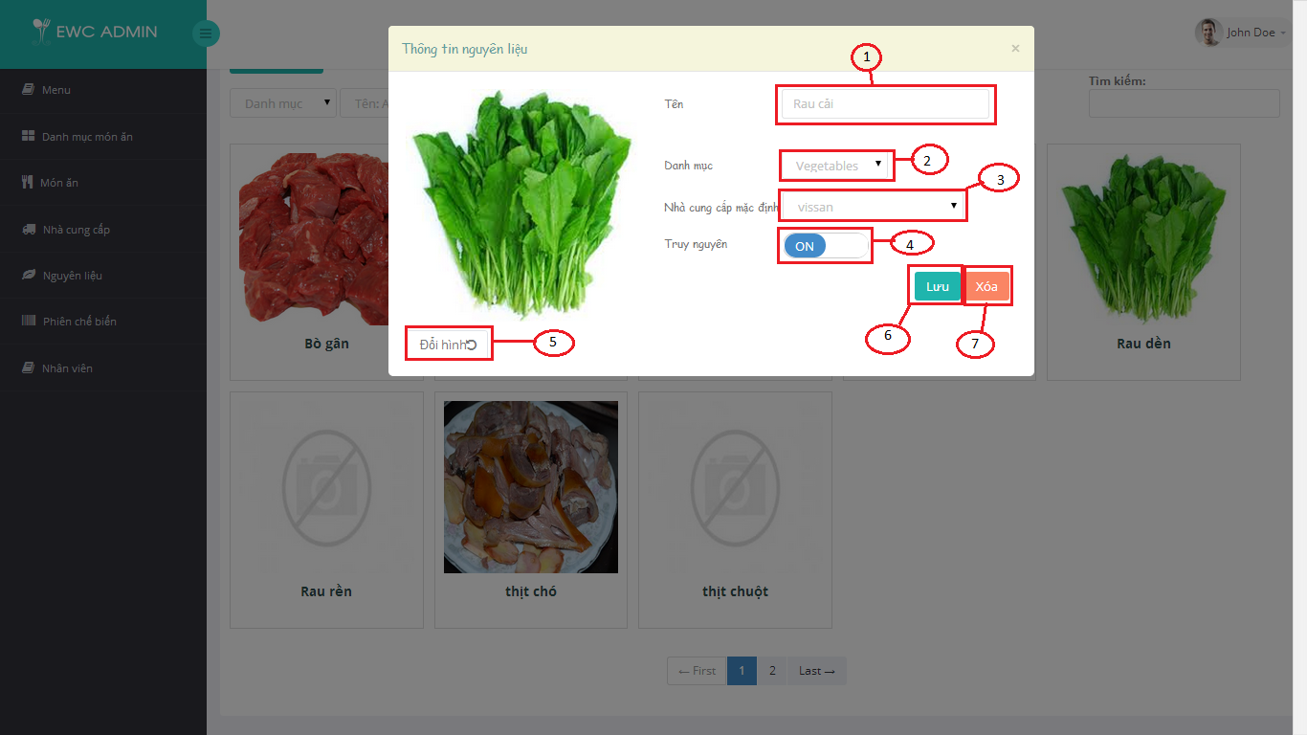

Figure 5.21 Update ingredient screen

|  |  |  |  |
| --- | --- | --- | --- |
| **No.** | **Name** | **Type** | **Description** |
| **1** | “Tên” | Textbox | Name of ingredient. |
| **2** | “Danh mục” | Category | Category of ingredient. |
| **3** | “Nhà cung cấp mặc định” | Category | Supplier default of ingredient. |
| **4** | “Truy nguyên” | switch | Tracibility of ingredient |
| **5** | “Đổi hình” | File | Change image of ingredient |
| **6** | “Lưu” | button | Save information of ingredient. |
| **7** | “Xóa” | button | Delete ingredient. |

Table 5.16: Update ingredient screen decription.

##### Manage User

##### 4.2.1.6.1 View User

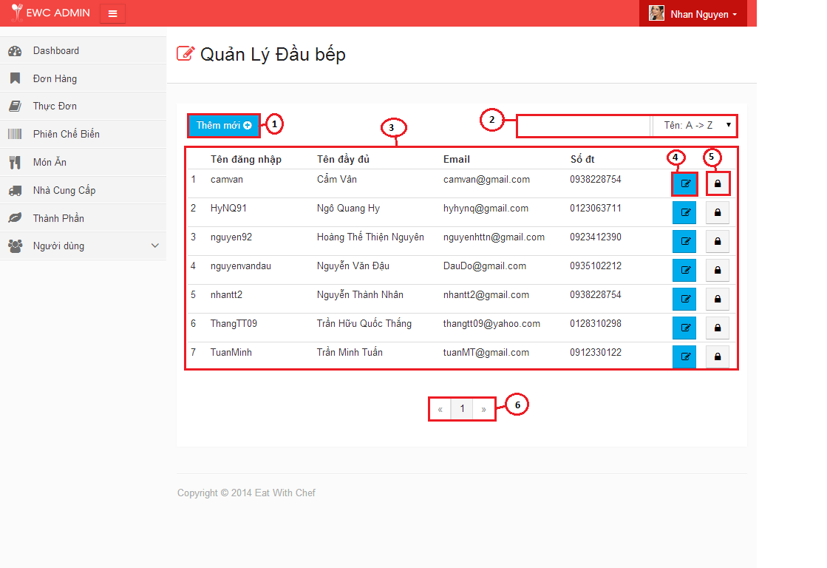

Figure 5.19 View user screen

|  |  |  |  |
| --- | --- | --- | --- |
| **No.** | **Name** | **Type** | **Description** |
| **1** | “Thêm mơi” | Button | Display pop up window to create new user. |
| **2** | Search form | Form | Filter, sort, and search user by name, category. |
| **3** | List of user | Table | Display all User. |
| **4** | Edit button | Button | Display pop up window to edit user. |
| **5** | Lock button | Button | Delete user. |
| **6** | Page | Form | Paging list user. |

Table 5.16: View user screen decription.

##### 4.2.1.6.2 Create Staff

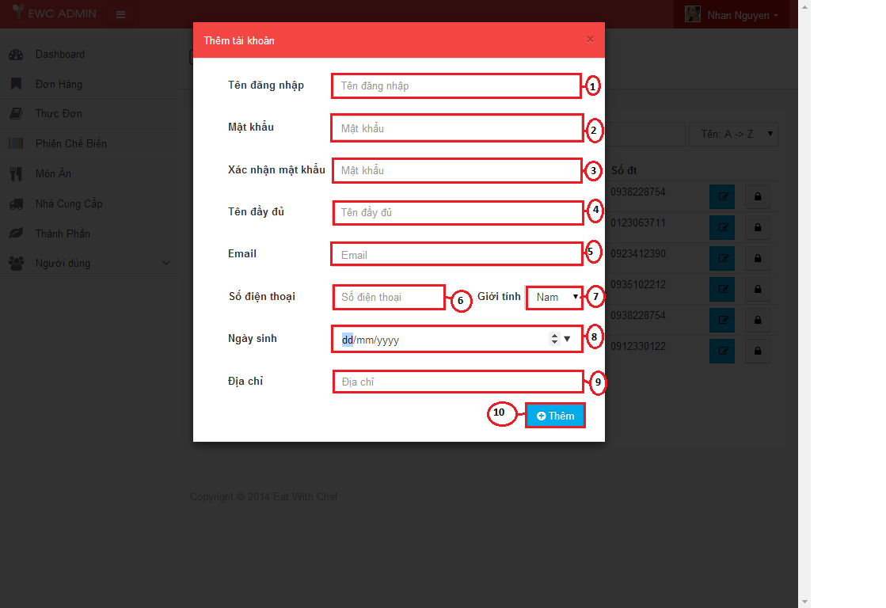

Figure 5.19 Create user screen

|  |  |  |  |
| --- | --- | --- | --- |
| **No.** | **Name** | **Type** | **Description** |
| **1** | “Tên đăng nhập” | Textbox | Input username of user. |
| **2** | “Mật khẩu” | Textbox | Input password of user |
| **3** | “Xác nhận mật khẩu” | Textbox | Input repassword of user. |
| **4** | “Tên đầy đủ” | Textbox | Input full name of user. |
| **5** | “Email” | Textbox | Input email of user |
| **6** | “Sồ điện thoại” | Textbox | Input phone number of user. |
| **7** | “Giới tính” | Dropdown List | Input gender of user. |
| **8** | “Ngày sinh” | Date | Input birthday of user. |
| **9** | “Địa chỉ” | Textbox | Input address of user. |
| **10** | “Lưu” | Button | Create user. |

Table 5.16: Create user screen decription.

##### 4.2.1.6.2 Create Chef

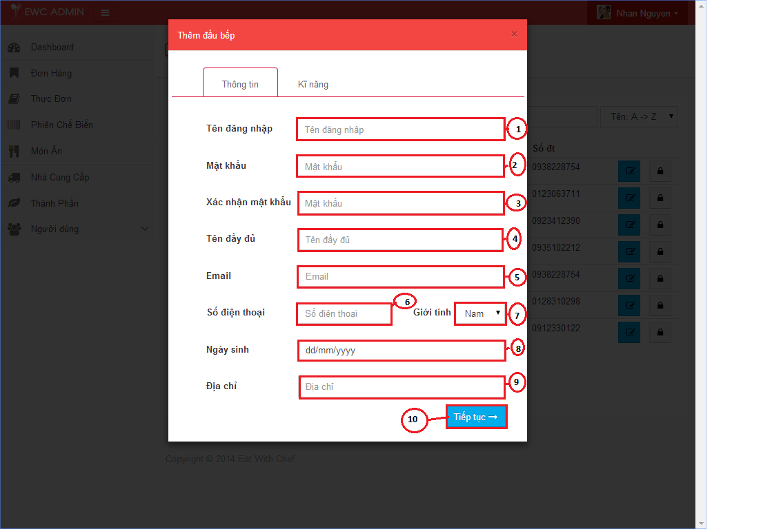

|  |  |  |  |
| --- | --- | --- | --- |
| **No.** | **Name** | **Type** | **Description** |
| **1** | “Tên đăng nhập” | Textbox | Input username of user. |
| **2** | “Mật khẩu” | Textbox | Input password of user |
| **3** | “Xác nhận mật khẩu” | Textbox | Input repassword of user. |
| **4** | “Tên đầy đủ” | Textbox | Input full name of user. |
| **5** | “Email” | Textbox | Input email of user |
| **6** | “Sồ điện thoại” | Textbox | Input phone number of user. |
| **7** | “Ngày sinh” | Date | Input birthday of user. |
| **8** | “Địa chỉ” | Textbox | Input address of user. |
| **9** | “Giới tính” | Dropdown List | Input gender of user. |
| **10** | “Tiếp tục” | Button | Display Tab skill of Chef. |

##### 4.2.1.6.3 Choose skill of chef

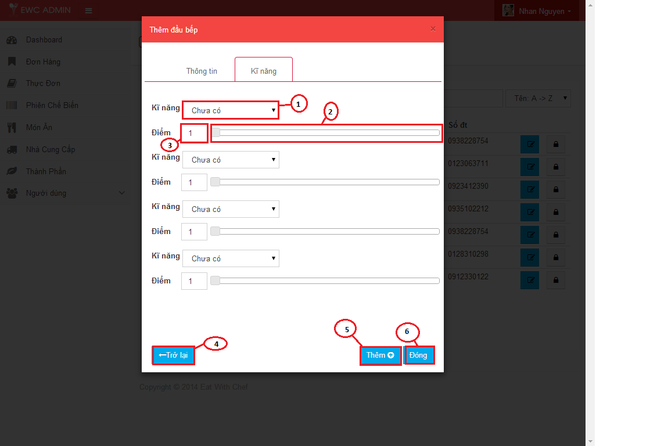

Figure 5.19 Edit user screen

|  |  |  |  |
| --- | --- | --- | --- |
| **No.** | **Name** | **Type** | **Description** |
| **1** | “Kĩ năng” | Dropdown list | List of skill. |
| **2** | Slider of core | Slider | Slider of score of skill. |
| **3** | “Điểm” | Textbox | Mark of skill. |
| **4** | “Trở lại” | Button | Return to information of chef tab. |
| **5** | “Thêm” | Button | Save chef, |
| **6** | “Đóng” | Button | Close pop up window. |

Table 5.16:Choose skill of chef screen decription.

# 4.2.1.7 Sequence Diagram

##### 4.2.1.7 Manage Supplier

##### 4.2.1.7.1 Show supplier

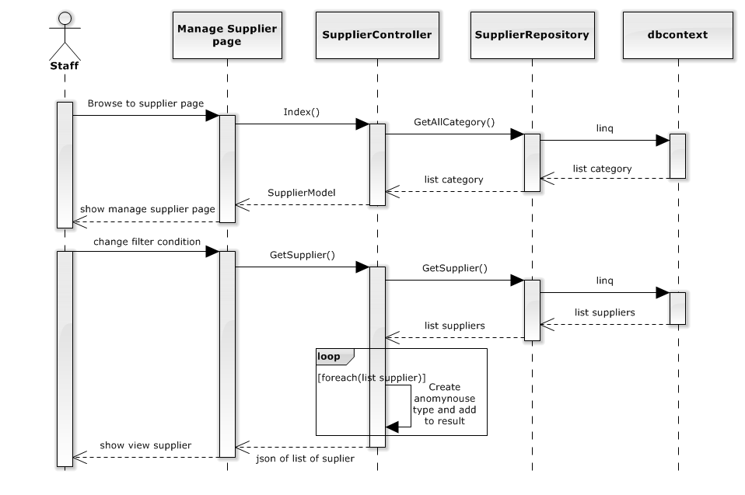

##### 4.2.1.7.2 Create supplier

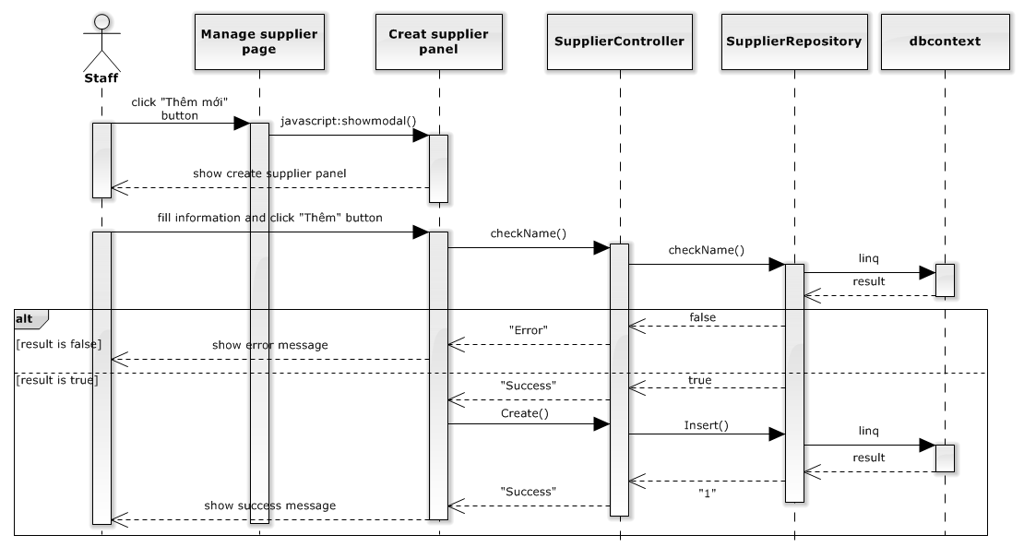

##### 4.2.1.7.2 Edit supplier

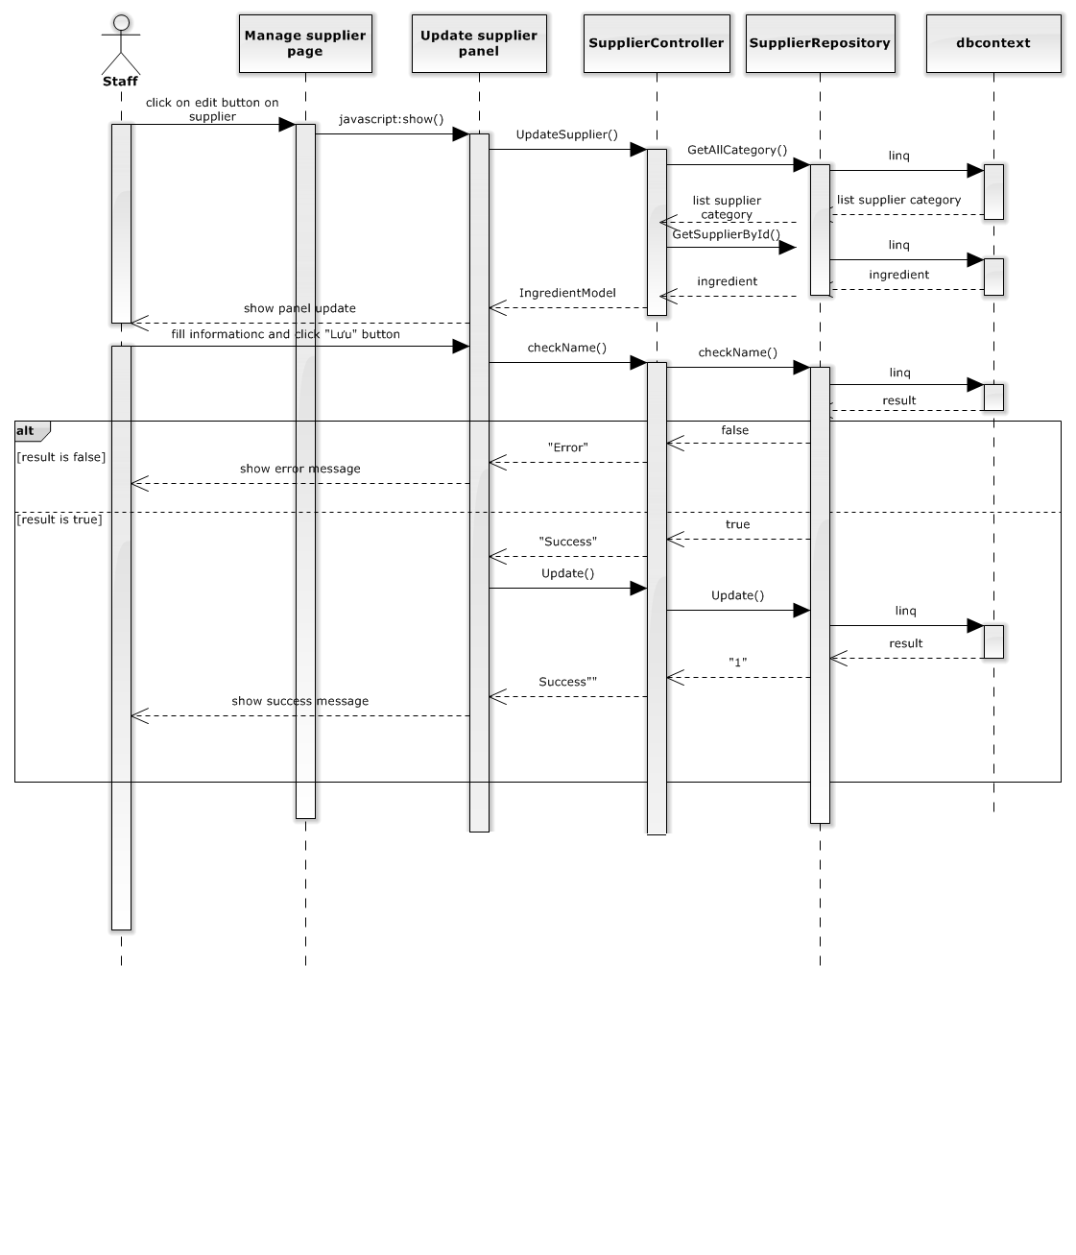

##### 4.2.1.7.2 Update Default supplier for ingredient

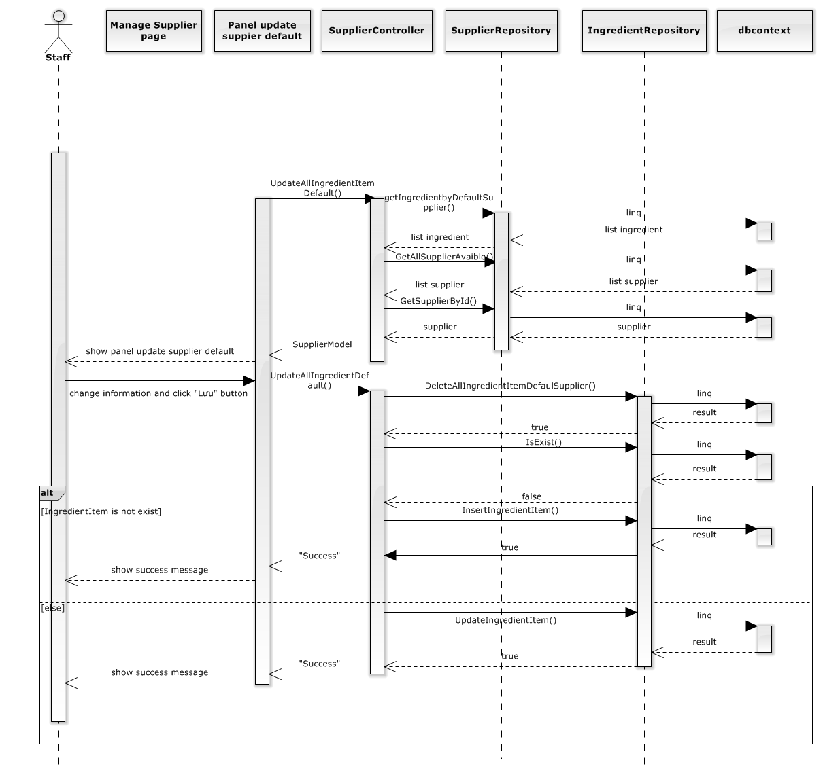

##### 4.2.1.7.2 Delete supplier

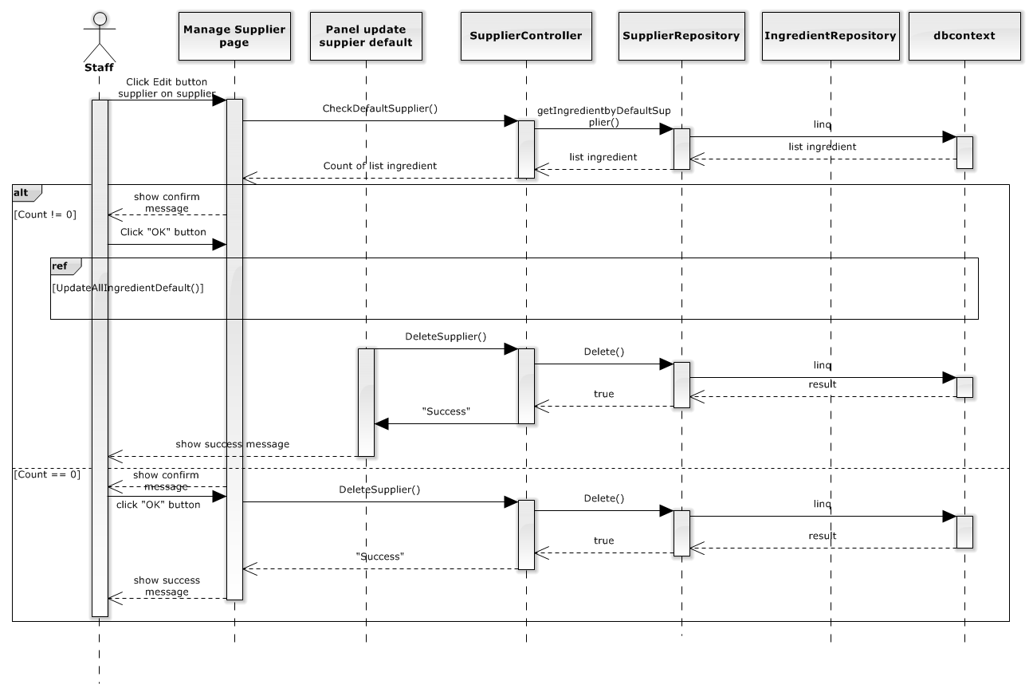

##### 4.2.1.7.2 Restore supplier

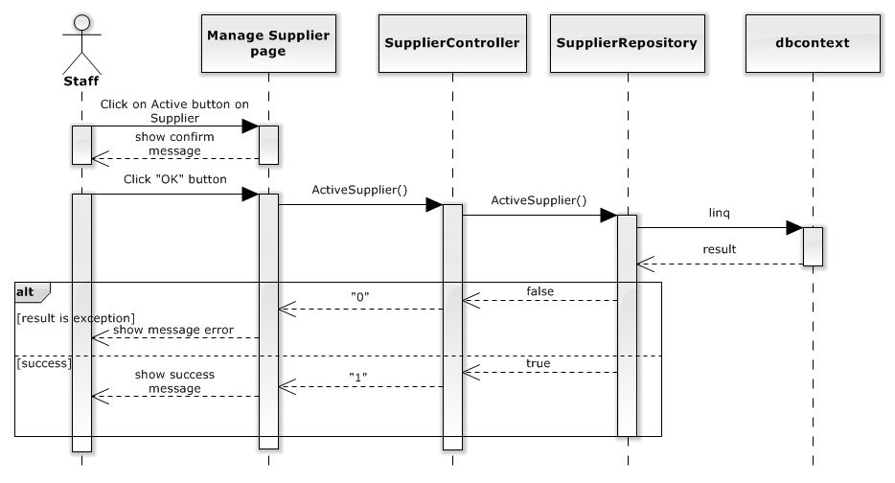

##### 4.2.1.7.2 Manage Ingredient

##### 4.2.1.7.2 Show Ingredient

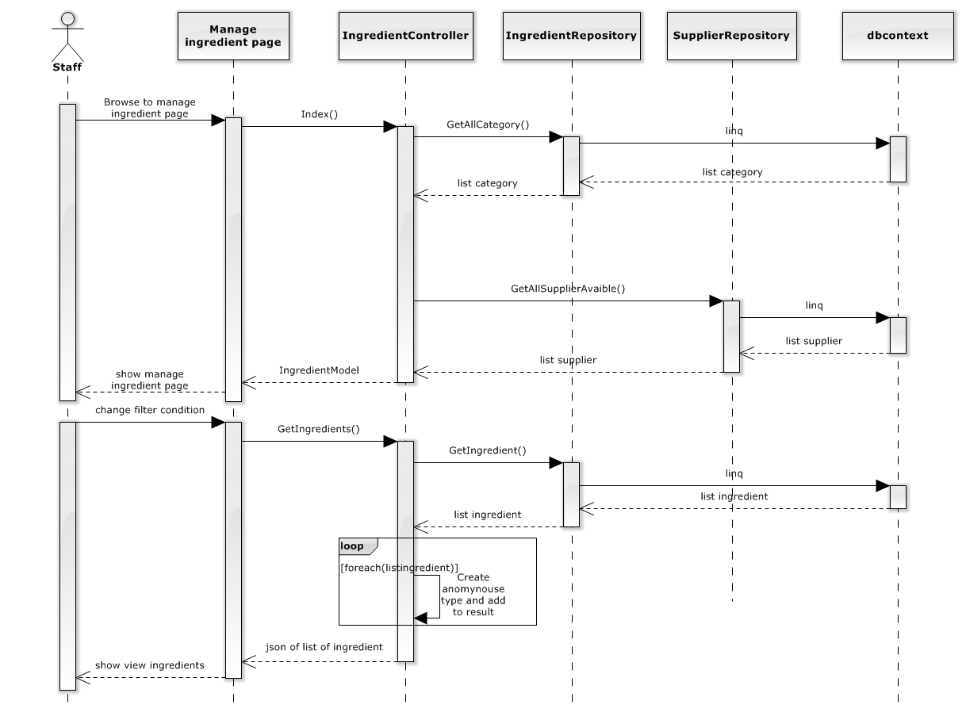

##### 4.2.1.7.2 Create Ingredient

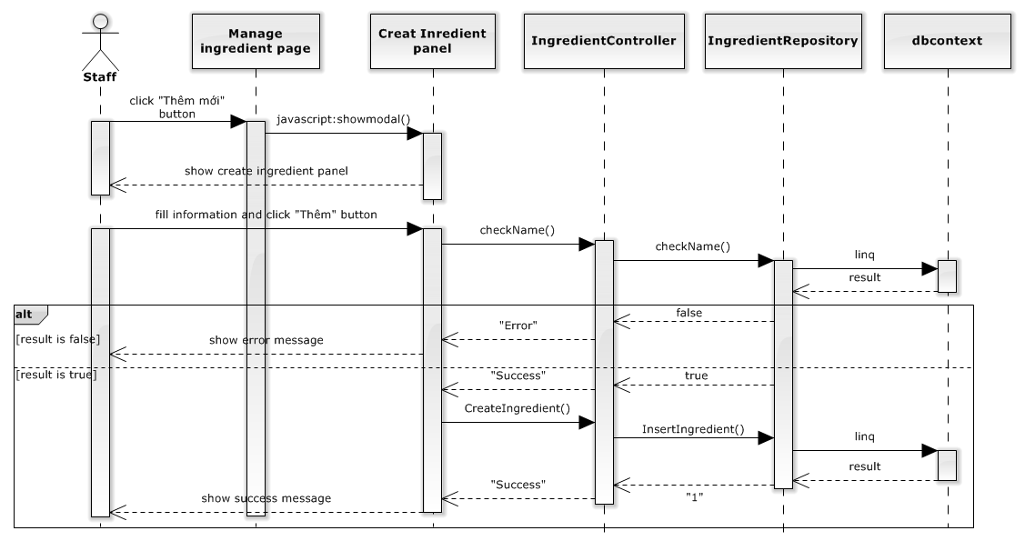

##### 4.2.1.7.2 Edit Ingredient

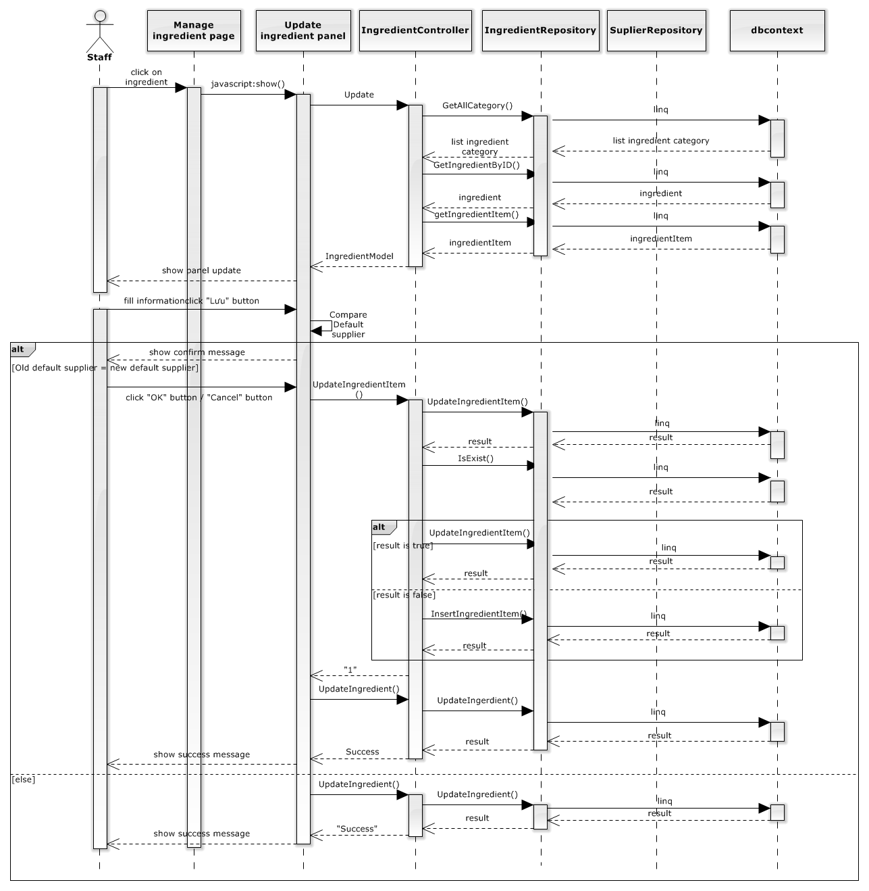

##### 4.2.1.7.2 Delete Ingredient

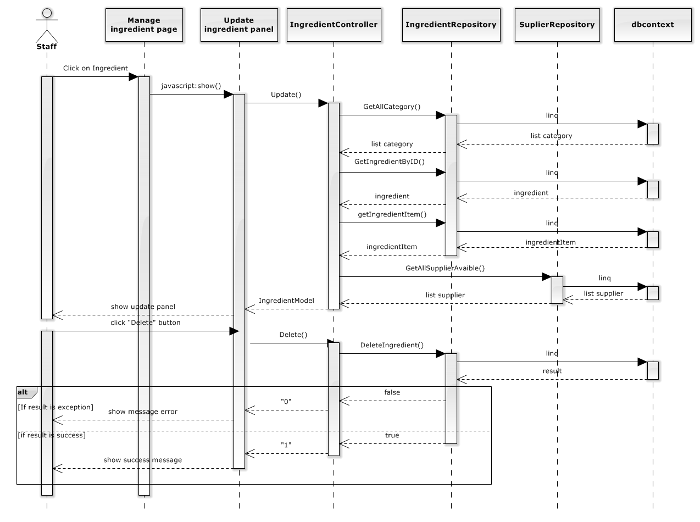

##### 4.2.1.9 Manage user

##### 4.2.1.9.1 Show user

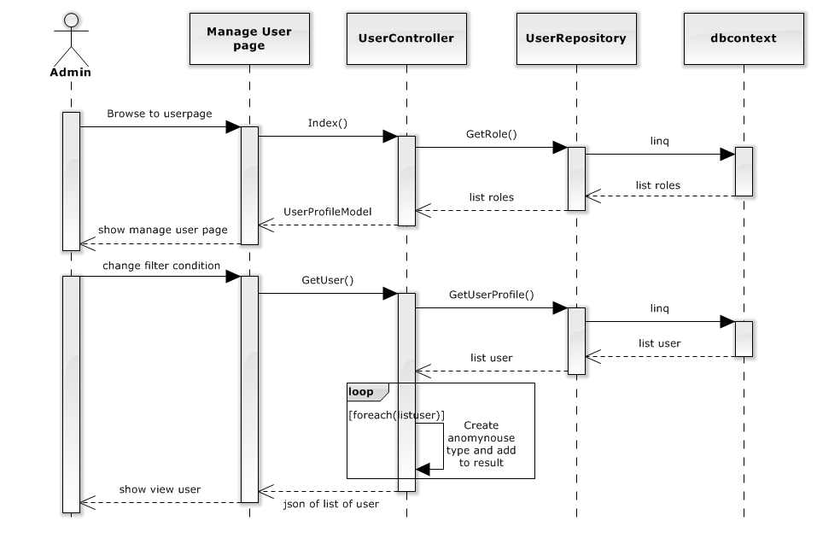

##### 4.2.1.9.1 Create user

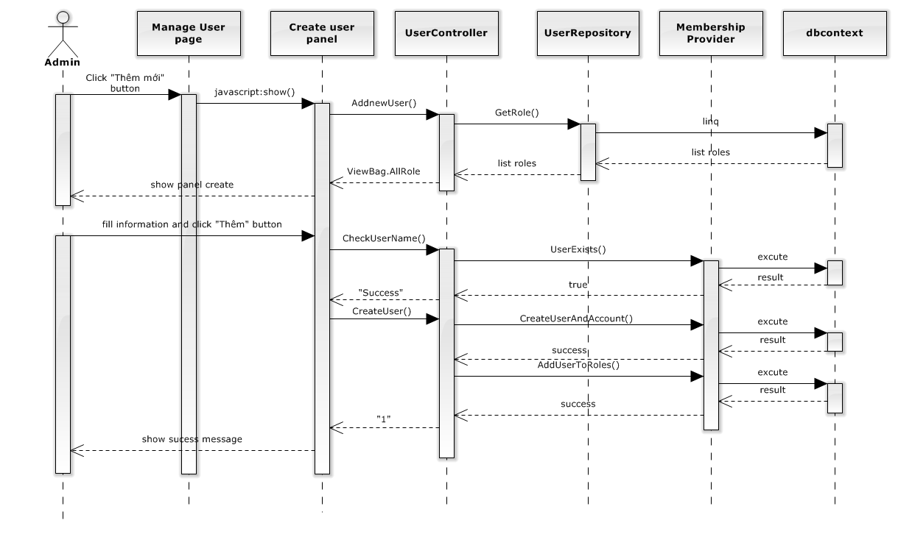

##### 4.2.1.9.1 Edit role of user

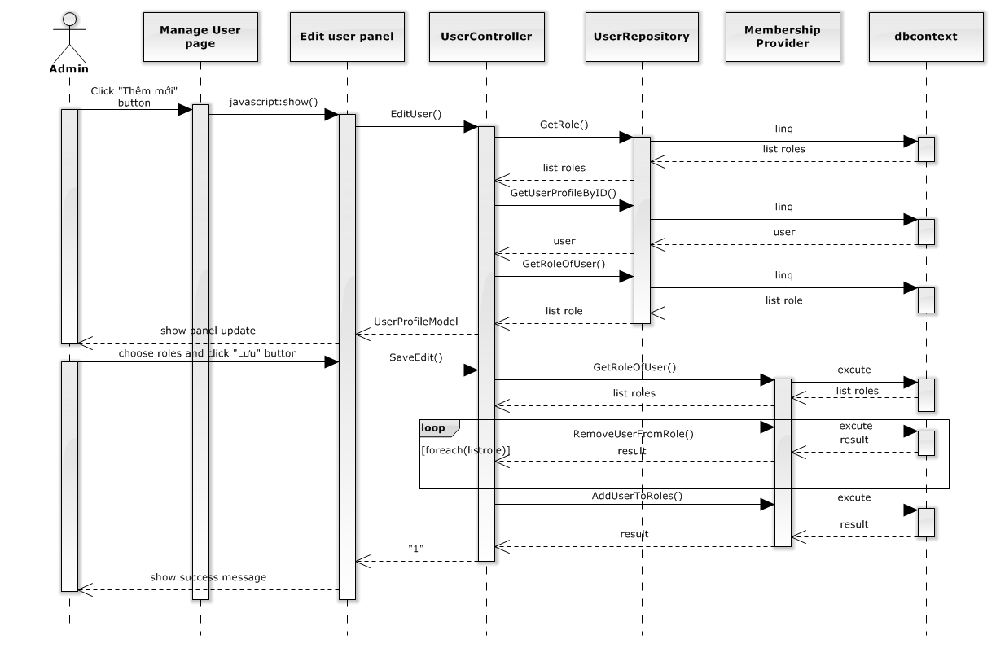

##### 4.2.1.9.1 DeActive user

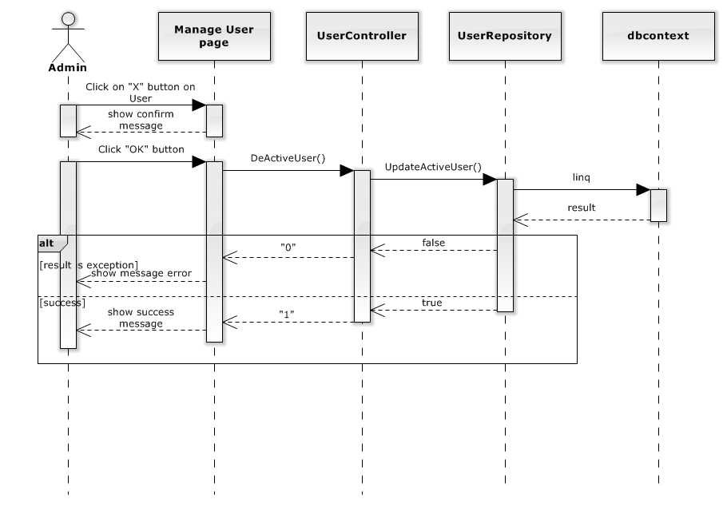

##### 4.2.1.9.1 Active user

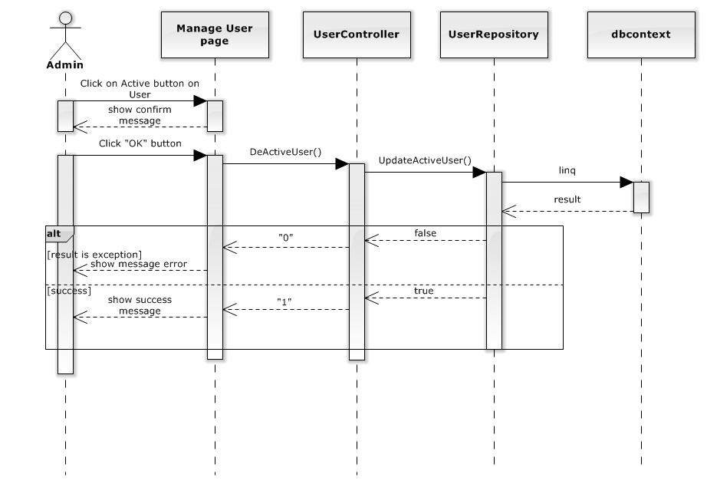

##### 4.2.1.10 Test case Supplier

| **ID** | **Test Case Description** | **Test Case Procedure** | **Expected Output** | **Dependence** | **Result** | **Test Date** |
| --- | --- | --- | --- | --- | --- | --- |
|  | **Show Supplier** |  |  |  |  |  |
| SS001 | Test viewing Supplier with filter conditions successfully | 1. Staff clicks “Nhà cung cấp” in the menu bar.  2. Staff enter “Vissan” in the search input.  3. Staff choose page 2.  4. Staff selectes “Nhỏ” in Category filter. | 1. “Quản lý Món Ăn” page shows up.  2. All supplier contain the word “Vissan” in their name shown in the table.  3. Go to page 2 of the result suppliers.  4. No result will be found |  |  | 25/07/2013 |
|  | **Create Supplier** |  |  |  |  | 30/07/2013 |
| CS001 | Staff create a new supplier successfully | 1. Staff clicks “Thêm mới” buton.  2. Staff types “Coopmart” for “Tên”, choose “Lớn” for “Danh mục”, “01203036040” for “Số điện thoại”, “Ho Chi Minh City, Vietnam” for “Địa chỉ” and click “Thêm” button. | 1. “Thêm Nhà cung cấp” panel shows up.  2. A message “Thêm nhà cung cấp thành công” appear in the screen and “Thêm Nhà cung cấp” panel is disapeared. |  |  | 30/07/2013 |
| CS002 | Test error message appear if there are empty fields. | 1. Staff clicks “Thêm mới” buton.  2. Staff leave all field is emty and click “Thêm” button. | 1. “Thêm Nhà cung cấp” panel shows up.  2. Error message “Không được để trống!” for “Tên”. Error message “Không được để trống!” for “Số điện thoại”. Error message “Không được để trống!” for “Địa chỉ”. |  |  |  |
| CS003 | Test error message appear if Supplier name is existed. | 1. Staff clicks “Thêm mới” buton.  2. Staff types “Vissan” for “Tên”, choose “Lớn” for “Danh mục”, “01203036040” for “Số điện thoại”, “Ho Chi Minh City, Vietnam” for “Địa chỉ” and click “Thêm” button. | 1. “Thêm Nhà cung cấp” panel shows up.  2. Error message “Tên này đã tồn tại!” below “Tên” field. |  |  |  |
| CS004 | Test error message appear if Supplier Address is not valid. | 2. Staff types “Thắng lợi” for “Tên”, choose “Lớn” for “Danh mục”, “01203036040” for “Số điện thoại”, “abbbccccccc” for “Địa chỉ” and click “Thêm” button. | 1. “Thêm Nhà cung cấp” panel shows up.  2. Error message “Hãy chọn địa chỉ đúng trên bản đồ” below “Địa chỉ” field. |  |  |  |
| CS005 | Test error message appear if Supplier phone is not valid. | 2. Staff types “Thắng lợi” for “Tên”, choose “Lớn” for “Danh mục”, “sdsdsds” for “Số điện thoại”, “abbbccccccc” for “Địa chỉ” and click “Thêm” button. | 1. “Thêm Nhà cung cấp” panel shows up.  2. Error message “Số điện thoại không hợp lệ” below “Số điện thoại” field. |  |  |  |
|  | **Update Supplier** |  |  |  |  |  |
| CS001 | Staff update a supplier successfully | 1. Staff clicks D:\Deletebtn.png buton on Vissan.  2. Staff modifies “Vissan A” for “Tên”, choose “Nhỏ” for “Danh mục”, “01203036041” for “Số điện thoại”, “Ho Chi Minh City, Vietnam” for “Địa chỉ” and click “Lưu” button. | 1. “Thông tin nhà cung cấp” panel shows up.  2. A message “Cập nhập nhà cung cấp thành công” appear in the screen and “Thông tin nhà cung cấp” panel is disappeared. |  |  | 30/07/2013 |
| CS002 | Test error message appear if there are empty fields. | 1. Staff clicks D:\Deletebtn.png buton on Coopmart.  2. Staff leave all field is emty and click “Lưu” button. | 1. “Thông tin nhà cung cấp” panel shows up.  2. Error message “Không được để trống!” for “Tên”. Error message “Không được để trống!” for “Số điện thoại”. Error message “Không được để trống!” for “Địa chỉ”. |  |  |  |
| CS003 | Test error message appear if Supplier name is existed. | 1. Staff clicks D:\Deletebtn.png buton on Thắng lợi.  2. Staff modifies “Vissan” for “Tên”, choose “Nhỏ” for “Danh mục”, “01203036041” for “Số điện thoại”, “Ho Chi Minh City, Vietnam” for “Địa chỉ” and click “Lưu” button. | 1. “Thông tin nhà cung cấp” panel shows up.  2. Error message “Tên này đã tồn tại!” below “Tên” field. |  |  |  |
| CS004 | Test error message appear if Supplier Address is not valid. | 1. Staff clicks D:\Deletebtn.png buton on Thắng lợi.  2. Staff modifies “Vissan A” for “Tên”, choose “Nhỏ” for “Danh mục”, “01203036041” for “Số điện thoại”, “1233412” for “Địa chỉ” and click “Lưu” button. | 1. “Thêm Nhà cung cấp” panel shows up.  2. Error message “Địa chỉ không đúng” below “Địa chỉ” field. |  |  |  |
| CS005 | Test error message appear if Supplier phone is not valid. | 1. Staff clicks D:\Deletebtn.png buton on Coopmart.  2. Staff modifies “Vissan A” for “Tên”, choose “Nhỏ” for “Danh mục”, “01203sds036041” for “Số điện thoại”, “Ho Chi Minh City, Vietnam” for “Địa chỉ” and click “Lưu” button. | 1. “Thêm Nhà cung cấp” panel shows up.  2. Error message “Số điện thoại không hợp lệ” below “Số điện thoại” field. |  |  |  |
|  | **Delete Supplier** |  |  |  |  |  |
| UD001 | Test delete a supplier successfully if this supplier is not default of any ingredient. | 1. Staff clicks D:\Editbutton.png button on vissan.  2. Staff clicks “OK” button. | 1. Show confirm message ”Bạn có chắc chắn muốn xóa!”.  2. A message “Xóa nhà cung cấp thành công” appear in the screen. |  |  | 30/07/2013 |
| UD001 | Test delete a supplier successfully if this supplier is default of any ingredient. | 1. Staff clicks D:\Editbutton.png button on Coopmart.  2. Staff clicks “OK” button.  3.Staff choose default supplier and click “Lưu” button. | 1. Show confirm message ”Vì CoopMart là nhà cung cấp mặc định của 1 số nguyên liệu khác, Muốn xóa, bạn phải chọn nhà cung cấp mặc định cho các nguyên liệu đó?”.  2. “Cập nhập nhà cung cấp mặc định sau khi xóa Coopmart” panel show up.  3. This panel is disappeared and a message “Xóa nhà cung cấp thành công” appear in the screen. |  |  | 30/07/2013 |
|  | **Restore Supplier** |  |  |  |  |  |
| UD001 | Test restore a supplier successfully. | 1. Staff clicks D:\restorebtn.png button on Coopmart.  2. Staff clicks “OK” button. | 1. Show confirm message ”Bạn có chắc chắn muốn phục hồi nhà cung cấp này”.  2. A message “Phục hồi nhà cung cấp thành công” appear in the screen. |  |  | 30/07/2013 |

##### 4.2.1.11 Test case Ingredient

| **ID** | **Test Case Description** | **Test Case Procedure** | **Expected Output** | **Dependence** | **Result** | **Test Date** |
| --- | --- | --- | --- | --- | --- | --- |
|  | **Show Ingredient** |  |  |  |  |  |
| SS001 | Staff viewing Ingredient with filter conditions successfully | 1. Staff clicks “Nguyên liệu” in the menu bar.  2. Staff enter “thịt gà” in the search input.  3. Staff choose page 2.  4. Staff selectes “Rau” in Category filter. | 1. “Quản lý Nguyên liệu” page shows up.  2. All ingredient contain the word “thịt gà” in their name shown in the table.  3. Go to page 2 of the result ingredients.  4. No result will be found |  |  | 25/07/2013 |
|  | **Create Ingredient** |  |  |  |  | 30/07/2013 |
| CS001 | Test creating a new ingredient successfully | 1. Staff clicks “Thêm mới” buton.  2. Staff types “Rau hổ” for “Tên”, choose “Rau” for “Danh mục”, choose “Vissan” for “Nhà cung cấp mặc định”, chooses image and click “Thêm” button. | 1. “Thêm Nguyên liệu” panel shows up.  2. A message “Thêm Nguyên liệu” appear in the screen and “Thêm Nguyên liệu” panel is disapeared. |  |  | 30/07/2013 |
| CS002 | Test error message appear if there are empty fields. | 1. Staff clicks “Thêm mới” buton.  2. Staff leave “Tên” field is emty and click “Thêm” button. | 1. “Thêm Nguyên liệu” panel shows up.  2. Error message “Không được để trống!” for “Tên”. |  |  |  |
| CS003 | Test error message appear if ingredient name is existed. | 1. Staff clicks “Thêm mới” buton.  2. Staff types “Thịt bò” for “Tên”, choose “Thịt” for “Danh mục”, choose “Vissan” for “Nhà cung cấp mặc định”, chooses image and click “Thêm” button. | 1. “Thêm Nguyên liệu” panel shows up.  2. Error message “Tên này đã tồn tại!” below “Tên” field. |  |  |  |
|  | **Update Ingredient** |  |  |  |  |  |
| CS001 | Test updating a ingredient successfully in case don’t change the ”Nhà cung cấp mặc định” field. | 1. Staff clicks on “Thịt bò”.  2. Staff modifies “Thịt bò A” for “Tên”, choose “Thịt” for “Danh mục”, choose “Coopmart” for “Nhà cung cấp mặc định”, chooses image, change “Truy nguyên” to “OFF” and click “Lưu” button. | 1. “Thông tin Nguyên liệu” panel shows up.  2. A message “Cập nhập thành công” appear in the screen and “Thông tin Nguyên liệu” panel is disapeared. |  |  | 30/07/2013 |
| CS001 | Test updating a ingredient successfully in case change the ”Nhà cung cấp mặc định” field. | 1. Staff clicks on “Thịt bò”.  2. Staff modifies “Thịt bò A” for “Tên”, choose “Thịt” for “Danh mục”, choose “Vissan” for “Nhà cung cấp mặc định”, chooses image, change “Truy nguyên” to “OFF” and click “Lưu” button.  3. Click “OK”/”Cancel” button. | 1. “Thông tin Nguyên liệu” panel shows up.  2. A confirm message “Bạn có muốn Coopmart vẫn còn cung cấp Thịt bò không?” .  3. A message “Cập nhập thành công” appear in the screen and “Thông tin Nguyên liệu” panel is disapeared. |  |  | 30/07/2013 |
| CS002 | Test error message appear if there are empty fields. | 1. Staff clicks on “Thịt heo”.  2. Staff leave “Tên” field is emty and click “Lưu” button. | 1. “Thông tin Nguyên liệu” panel shows up.  2. Error message “Không được để trống!” for “Tên”. |  |  |  |
| CS003 | Test error message appear if ingredient name is existed. | 1. Staff clicks on “Thịt heo”.  2. Staff modifies “Thịt bò ” for “Tên”, choose “Thịt” for “Danh mục”, choose “Coopmart” for “Nhà cung cấp mặc định”, chooses image, change “Truy nguyên” to “OFF” and click “Lưu” button. | 1. “Thông tin Nguyên liệu” panel shows up.  2. Error message “Tên này đã tồn tại!” below “Tên” field. |  |  |  |
|  | **Delete Ingredient** |  |  |  |  |  |
| UD001 | Test delete a ingredient successfully. | 1. Staff clicks on “Thịt bò”.  2. Staff clicks “Xóa” button.  3. Staff clicks “OK” button. | 1. “Thông tin Nguyên liệu” panel shows up.  2. Show confirm message ”Bạn có chắc chắn muốn xóa!”.  3. A message “Xóa nhà cung cấp thành công” appear in the screen. |  |  | 30/07/2013 |

##### 4.2.1.12 Test case User

| **ID** | **Test Case Description** | **Test Case Procedure** | **Expected Output** | **Dependence** | **Result** | **Test Date** |
| --- | --- | --- | --- | --- | --- | --- |
|  | **Show User** |  |  |  |  |  |
| SS001 | Test viewing user with filter conditions successfully. | 1. Staff clicks “Nhà cung cấp” in the menu bar.  2. Staff enter “Vissan” in the search input.  3. Staff choose page 2.  4. Staff selectes “Nhỏ” in Category filter. | 1. “Quản lý Món Ăn” page shows up.  2. All supplier contain the word “Vissan” in their name shown in the table.  3. Go to page 2 of the result suppliers.  4. No result will be found |  |  | 25/07/2013 |
|  | **Create Supplier** |  |  |  |  | 30/07/2013 |
| CS001 | Staff create a new supplier successfully | 1. Staff clicks “Thêm mới” buton.  2. Staff types “Coopmart” for “Tên”, choose “Lớn” for “Danh mục”, “01203036040” for “Số điện thoại”, “Ho Chi Minh City, Vietnam” for “Địa chỉ” and click “Thêm” button. | 1. “Thêm Nhà cung cấp” panel shows up.  2. A message “Thêm nhà cung cấp thành công” appear in the screen and “Thêm Nhà cung cấp” panel is disapeared. |  |  | 30/07/2013 |
| CS002 | Test error message appear if there are empty fields. | 1. Staff clicks “Thêm mới” buton.  2. Staff leave all field is emty and click “Thêm” button. | 1. “Thêm Nhà cung cấp” panel shows up.  2. Error message “Không được để trống!” for “Tên”. Error message “Không được để trống!” for “Số điện thoại”. Error message “Không được để trống!” for “Địa chỉ”. |  |  |  |
| CS003 | Test error message appear if Supplier name is existed. | 1. Staff clicks “Thêm mới” buton.  2. Staff types “Vissan” for “Tên”, choose “Lớn” for “Danh mục”, “01203036040” for “Số điện thoại”, “Ho Chi Minh City, Vietnam” for “Địa chỉ” and click “Thêm” button. | 1. “Thêm Nhà cung cấp” panel shows up.  2. Error message “Tên này đã tồn tại!” below “Tên” field. |  |  |  |
| CS004 | Test error message appear if Supplier Address is not valid. | 2. Staff types “Thắng lợi” for “Tên”, choose “Lớn” for “Danh mục”, “01203036040” for “Số điện thoại”, “abbbccccccc” for “Địa chỉ” and click “Thêm” button. | 1. “Thêm Nhà cung cấp” panel shows up.  2. Error message “Hãy chọn địa chỉ đúng trên bản đồ” below “Địa chỉ” field. |  |  |  |
| CS005 | Test error message appear if Supplier phone is not valid. | 2. Staff types “Thắng lợi” for “Tên”, choose “Lớn” for “Danh mục”, “sdsdsds” for “Số điện thoại”, “abbbccccccc” for “Địa chỉ” and click “Thêm” button. | 1. “Thêm Nhà cung cấp” panel shows up.  2. Error message “Số điện thoại không hợp lệ” below “Số điện thoại” field. |  |  |  |
|  | **Update Supplier** |  |  |  |  |  |
| CS001 | Staff update a supplier successfully | 1. Staff clicks D:\Deletebtn.png buton on Vissan.  2. Staff modifies “Vissan A” for “Tên”, choose “Nhỏ” for “Danh mục”, “01203036041” for “Số điện thoại”, “Ho Chi Minh City, Vietnam” for “Địa chỉ” and click “Lưu” button. | 1. “Thông tin nhà cung cấp” panel shows up.  2. A message “Cập nhập nhà cung cấp thành công” appear in the screen and “Thông tin nhà cung cấp” panel is disappeared. |  |  | 30/07/2013 |
| CS002 | Test error message appear if there are empty fields. | 1. Staff clicks D:\Deletebtn.png buton on Coopmart.  2. Staff leave all field is emty and click “Lưu” button. | 1. “Thông tin nhà cung cấp” panel shows up.  2. Error message “Không được để trống!” for “Tên”. Error message “Không được để trống!” for “Số điện thoại”. Error message “Không được để trống!” for “Địa chỉ”. |  |  |  |
| CS003 | Test error message appear if Supplier name is existed. | 1. Staff clicks D:\Deletebtn.png buton on Thắng lợi.  2. Staff modifies “Vissan” for “Tên”, choose “Nhỏ” for “Danh mục”, “01203036041” for “Số điện thoại”, “Ho Chi Minh City, Vietnam” for “Địa chỉ” and click “Lưu” button. | 1. “Thông tin nhà cung cấp” panel shows up.  2. Error message “Tên này đã tồn tại!” below “Tên” field. |  |  |  |
| CS004 | Test error message appear if Supplier Address is not valid. | 1. Staff clicks D:\Deletebtn.png buton on Thắng lợi.  2. Staff modifies “Vissan A” for “Tên”, choose “Nhỏ” for “Danh mục”, “01203036041” for “Số điện thoại”, “1233412” for “Địa chỉ” and click “Lưu” button. | 1. “Thêm Nhà cung cấp” panel shows up.  2. Error message “Địa chỉ không đúng” below “Địa chỉ” field. |  |  |  |
| CS005 | Test error message appear if Supplier phone is not valid. | 1. Staff clicks D:\Deletebtn.png buton on Coopmart.  2. Staff modifies “Vissan A” for “Tên”, choose “Nhỏ” for “Danh mục”, “01203sds036041” for “Số điện thoại”, “Ho Chi Minh City, Vietnam” for “Địa chỉ” and click “Lưu” button. | 1. “Thêm Nhà cung cấp” panel shows up.  2. Error message “Số điện thoại không hợp lệ” below “Số điện thoại” field. |  |  |  |
|  | **Delete Supplier** |  |  |  |  |  |
| UD001 | Test delete a supplier successfully if this supplier is not default of any ingredient. | 1. Staff clicks D:\Editbutton.png button on vissan.  2. Staff clicks “OK” button. | 1. Show confirm message ”Bạn có chắc chắn muốn xóa!”.  2. A message “Xóa nhà cung cấp thành công” appear in the screen. |  |  | 30/07/2013 |
| UD001 | Test delete a supplier successfully if this supplier is default of any ingredient. | 1. Staff clicks D:\Editbutton.png button on Coopmart.  2. Staff clicks “OK” button.  3.Staff choose default supplier and click “Lưu” button. | 1. Show confirm message ”Vì CoopMart là nhà cung cấp mặc định của 1 số nguyên liệu khác, Muốn xóa, bạn phải chọn nhà cung cấp mặc định cho các nguyên liệu đó?”.  2. “Cập nhập nhà cung cấp mặc định sau khi xóa Coopmart” panel show up.  3. This panel is disappeared and a message “Xóa nhà cung cấp thành công” appear in the screen. |  |  | 30/07/2013 |
|  | **Restore Supplier** |  |  |  |  |  |
| UD001 | Test restore a supplier successfully. | 1. Staff clicks D:\restorebtn.png button on Coopmart.  2. Staff clicks “OK” button. | 1. Show confirm message ”Bạn có chắc chắn muốn phục hồi nhà cung cấp này”.  2. A message “Phục hồi nhà cung cấp thành công” appear in the screen. |  |  | 30/07/2013 |

# 4.2.1.12 Class diagram

##### 4.2.1.12 Supplier

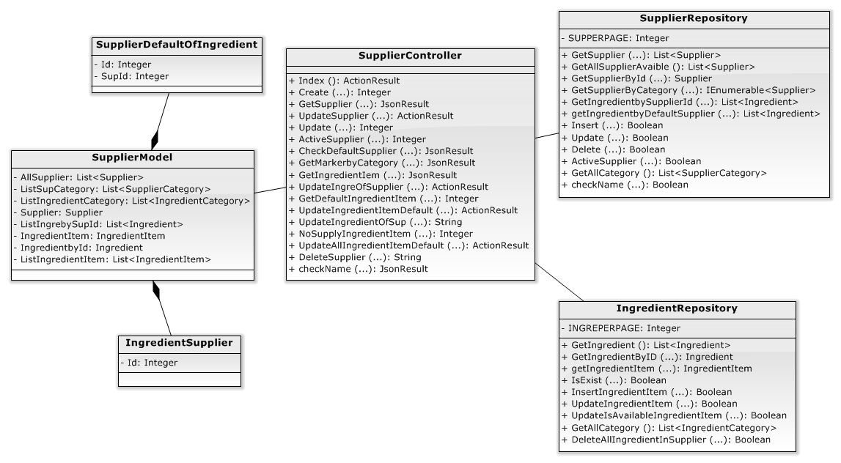

##### 4.2.1.12 SupplierController

|  |  |
| --- | --- |
| Class name | SupplierController |
| Description | This class excute all actions of supplier. |
| **Attribute**:   |  |  |  |  | | --- | --- | --- | --- | | **Attribute** | **Attribute Type** | **Data Type** | **Description** | | N/A | N/A | N/A | N/A | | |
|  | |
| **Methods**:  *Public ActionResult Index():* Get view of supplier.   |  |  |  | | --- | --- | --- | | **Parameter/Return** | **Type** | **Description** | | Return | ActionResult | View of supplier |   *Public int Create(string name,string Address, string Phone,* *double Latitude, double Longitude, int SupplierCategory ):* System call method of SupplierRepository to create new supplier.   |  |  |  | | --- | --- | --- | | **Parameter/Return** | **Type** | **Description** | | Return | Interger | SUCCESS: “1”  ERROR: “0” | | name | String | Name of supplier | | Address | String | Address of supplier | | Phone | String | Phone number of supplier | | Latitude | Double | Latitude of supplier | | Longitude | Double | Longitude of supplier. | | SupplierCategory | Interger | Category of supplier. |   *Public JsonResult GetSupplier(string keyword, int categoryID, string sortBy, string sortDirection, int page):* System call method of SupplierRepository to get all supplier after filter and search.   |  |  |  | | --- | --- | --- | | **Parameter/Return** | **Type** | **Description** | | Return | JsonResult | Return List of supplier after filter and search. | | Keyword | String | Keyword of name of supplier. | | categoryID | Interger | CategoryId of supplier | | sortBy | String | Sort name. | | sortDirection | String | Sort direction. | | page | Interger | Page of supplier. |   *public ActionResult UpdateSupplier(int id):* System get view to update information of supplier.   |  |  |  | | --- | --- | --- | | **Parameter/Return** | **Type** | **Description** | | Return | ActionResult | Return PartialView to update supplier. | | Id | Interger | Id of supplier. |   *public int Update(int Id, string Name, string Address, string Phone, double Latitude, double Longitude, int SupplierCategory):* System call method of SupplierRepository to update supplier.   |  |  |  | | --- | --- | --- | | **Parameter/Return** | **Type** | **Description** | | Return | Interger | SUCCESS: “1”  ERROR: “0” | | Id | Interger | Id of supplier. | | Name | String | Name of supplier | | Address | String | Address of supplier | | Phone | String | Phone number of supplier | | Latitude | Double | Latitude of supplier | | Longitude | Double | Longitude of supplier. | | SupplierCategory | Interger | Category of supplier. |   *public int ActiveSupplier(int supid):* System call method of SupplierRepository to restore supplier after delete.   |  |  |  | | --- | --- | --- | | **Parameter/Return** | **Type** | **Description** | | Return | Interger | SUCCESS: “1”.  ERROR: “0”. | | supid | Interger | Id of supplier. |   *public ActionResult CheckDefaultSupplier(int supid):* System call method of SupplierRepository to check this is default or not of ingredients.   |  |  |  | | --- | --- | --- | | **Parameter/Return** | **Type** | **Description** | | Return | ActionResult | Return count of list ingredients. | | supid | Interger | Id of supplier. |   *public JsonResult GetMarkerbyCategory(int id):* System call method of SupplierRepository to get list of supplier after filter by category.   |  |  |  | | --- | --- | --- | | **Parameter/Return** | **Type** | **Description** | | Return | JsonResult | Return list of supplier after filter by category. | | supid | Interger | Id of supplier. |   *public JsonResult GetIngredientIem(int id, string keyword, int categoryID, string sortBy, string sortDirection, string except_ingredient):* System call method of IngredientRepository to get list of Ingredient item after filter and search.   |  |  |  | | --- | --- | --- | | **Parameter/Return** | **Type** | **Description** | | Return | JsonResult | Return List of ingredient item after filter and search. | | Id | Interger | Id of supplier. | | Keyword | String | Keyword of name of ingredient. | | categoryID | Interger | CategoryId of ingredient. | | sortBy | String | Sort name. | | sortDirection | String | Sort direction. | | Except_ingredient | String | List of id of ingredient to Except. |   *public ActionResult UpdateIngreOfSupplier(int id):* System get view to update ingredient of supplier.   |  |  |  | | --- | --- | --- | | **Parameter/Return** | **Type** | **Description** | | Return | ActionResult | Return PartialView to update supplier. | | id | Interger | Id of supplier. |   *public int GetDefaultIngredientItem(int ingreid):* System call method of IngredientRepository to get id of supplier which is supplier default of ingredient.   |  |  |  | | --- | --- | --- | | **Parameter/Return** | **Type** | **Description** | | Return | Interger | Return Id of supplier. | | id | Interger | Id of ingredient. |   *public ActionResult UpdateIngredientItemDefault(int supid, int ingreid):* System get View to update another Supplier default for ingredient if remove this ingredient from supplier.   |  |  |  | | --- | --- | --- | | **Parameter/Return** | **Type** | **Description** | | Return | ActionResult | Return PartialView to update supplier default of ingredient. | | supid | Interger | Id of supplier. | | ingreid | Interger | Id of ingredient. |   *public string UpdateIngredientOfSup(string info, int SupId): ):* System call method of IngredientRepository to update ingredient of supplier.   |  |  |  | | --- | --- | --- | | **Parameter/Return** | **Type** | **Description** | | Return | String | SUCCESS: “Success”.  ERROR: “Fail”. | | info | String | List of ingredient id. | | SupId | Interger | Id of supplier. |   *public int NoSupplyIngredientItem(int oldsupId, int ingreid, int newsupid):* System call method of IngredientRepository to update another Supplier default for ingredient if remove this ingredient from supplier.   |  |  |  | | --- | --- | --- | | **Parameter/Return** | **Type** | **Description** | | Return | Interger | SUCCESS: “1”.  ERROR: “0”. | | oldsupId | String | Old supplier id before remove ingredient. | | ingreid | Interger | Id of ingredient. | | newsupid | Interger | New supplier Id od ingredient. |   *public ActionResult UpdateAllIngredientItemDefault(int supid):* System get View to update another Supplier default for all ingredient if delete old default supplier.   |  |  |  | | --- | --- | --- | | **Parameter/Return** | **Type** | **Description** | | Return | ActionResult | Return PartialView to update supplier default of ingredient. | | supid | Interger | Id of supplier. |   *public string UpdateAllIngredientDefault(string info, int OldSupid):* System call method of IngredientRepository to update another Supplier default for all ingredient if delete old default supplier.   |  |  |  | | --- | --- | --- | | **Parameter/Return** | **Type** | **Description** | | Return | String | SUCCESS: “Success”.  ERROR: “Fail”. | | info | String | List of ingredient id and supplier id. | | OldSupId | Interger | Id of default supplier before update new default supplier. |   *public string DeleteSupplier(int id):* System call method of SupplierRepository to delete supplier.   |  |  |  | | --- | --- | --- | | **Parameter/Return** | **Type** | **Description** | | Return | String | SUCCESS: “Success”.  ERROR: “Fail”. | | supid | Interger | Id of supplier. |   *public JsonResult checkName(int id , string name):* System call method of SupplierRepository to check name of supplier is exist or not.   |  |  |  | | --- | --- | --- | | **Parameter/Return** | **Type** | **Description** | | Return | JsonResult | SUCCESS: “Success”.  ERROR: “Error”. | | id | Interger | Id of supplier category. | | name | String | Name of supplier. | | |

##### 4.2.1.12 SupplierRepository

|  |  |
| --- | --- |
| Class name | SupplierRopository |
| Description | This class excute all actions of supplier to database . |
| **Attribute**:   |  |  |  |  | | --- | --- | --- | --- | | **Attribute** | **Attribute Type** | **Data Type** | **Description** | | SUPPERPAGE | Input | Interger | Number of supplier per page. | | |
|  | |
| **Methods**:  *public List<Supplier> GetSupplier(string keyword, int categoryID, int page, string sortBy, string sortDirection, out int maxPage):* System excute to get all supplier after filter and search from database.   |  |  |  | | --- | --- | --- | | **Parameter/Return** | **Type** | **Description** | | Return | List<Supplier> | Return List of supplier after filter and search. | | keyword | String | Keyword of name of supplier. | | categoryID | Interger | CategoryId of supplier | | sortBy | String | Sort name. | | sortDirection | String | Sort direction. | | page | Interger | Page of supplier. | | maxPage | Interger | Max page of supplier. |   *public List<Supplier> GetAllSupplierAvaible():*System excute to get all supplier which is avaible from database.   |  |  |  | | --- | --- | --- | | **Parameter/Return** | **Type** | **Description** | | Return | List<Supplier> | Return List of supplier. |   *public Supplier GetSupplierById(int Id):* System excute to supplier by id from database.   |  |  |  | | --- | --- | --- | | **Parameter/Return** | **Type** | **Description** | | Return | Supplier | Return supplier. | | Id | Interger | Id of supplier. |   *public IEnumerable<Supplier> GetSupplierByCategory(int Id):* System excute to get list of suppliers by category from database.   |  |  |  | | --- | --- | --- | | **Parameter/Return** | **Type** | **Description** | | Return | IEnumerable<Supplier> | List of Supplier. | | Id | Interger | Id of supplier category. |   *public List<Ingredient> GetIngredientbySupplierId(int Id):* System excute to get list of ingredients of supplier from database.   |  |  |  | | --- | --- | --- | | **Parameter/Return** | **Type** | **Description** | | Return | List<Ingredient> | List of Ingredient. | | Id | Interger | Id of supplier. |   *public List<Ingredient> getIngredientbyDefaultSupplier(int supid)*: System excute to get list of ingredients by supplier which is default from database.   |  |  |  | | --- | --- | --- | | **Parameter/Return** | **Type** | **Description** | | Return | List<Ingredient> | Return list of ingredient. | | supid | Interger | Id of supplier. |   *public bool Insert(string name, string address, string phone, double lat, double lon, int SupCategory):* System excute to insert new supplier to database.   |  |  |  | | --- | --- | --- | | **Parameter/Return** | **Type** | **Description** | | Return | Boolean | SUCCESS: true  ERROR: false | | name | String | Name of supplier | | address | String | Address of supplier | | phone | String | Phone number of supplier | | lat | Double | Latitude of supplier | | long | Double | Longitude of supplier. | | SupCategory | Interger | Category of supplier. |   *public bool Update(int Id, string Name, string Address, string Phone, double Latitude, double Longitude, int SupplierCategory):* System excute to update supplier to database.   |  |  |  | | --- | --- | --- | | **Parameter/Return** | **Type** | **Description** | | Return | Boolean | SUCCESS: true  ERROR: false | | Id | Interger | Id of supplier. | | Name | String | Name of supplier | | Address | String | Address of supplier | | Phone | String | Phone number of supplier | | Latitude | Double | Latitude of supplier | | Longitude | Double | Longitude of supplier. | | SupplierCategory | Interger | Category of supplier. |   *public bool Delete(int SupplierId):* System excute to delete supplier to database.   |  |  |  | | --- | --- | --- | | **Parameter/Return** | **Type** | **Description** | | Return | Boolean | SUCCESS: true  ERROR: false | | SupplierId | Interger | Id of supplier. |   *public bool ActiveSupplier(int id)*: System excute to restore supplier to database.   |  |  |  | | --- | --- | --- | | **Parameter/Return** | **Type** | **Description** | | Return | Boolean | SUCCESS: true  ERROR: false | | id | Interger | Id of supplier. |   *public List<SupplierCategory> GetAllCategory()*: System excute to get category of supplier from database.   |  |  |  | | --- | --- | --- | | **Parameter/Return** | **Type** | **Description** | | Return | List<SupplierCategory> | Return List of category. |   *public bool checkName(int id, string name):* System excute to check name of supplier is exist or not from database.   |  |  |  | | --- | --- | --- | | **Parameter/Return** | **Type** | **Description** | | Return | Boolean | If name is exist, return true, else return false. | | id | Interger | Id of category of supplier. | | name | String | Name of supplier. | | |

##### 4.2.1.12 IngredientRepository

|  |  |
| --- | --- |
| Class name | IngredientRopository |
| Description | This class excute all actions of ingredient to database . |
| **Attribute**:   |  |  |  |  | | --- | --- | --- | --- | | **Attribute** | **Attribute Type** | **Data Type** | **Description** | | INGREPERPAGE | Input | Interger | Number of ingredient per page. | | |
|  | |
| **Methods**:  *public List<Ingredient> GetIngredient(string keyword, int categoryID, int page, string sortBy, string sortDirection,string[] except_ingredients, out int maxPage):* System excute to get all ingredient after filter and search from database.   |  |  |  | | --- | --- | --- | | **Parameter/Return** | **Type** | **Description** | | Return | List<Ingredient> | Return List of ingredient after filter and search. | | keyword | String | Keyword of name of supplier. | | categoryID | Interger | CategoryId of supplier | | sortBy | String | Sort name. | | sortDirection | String | Sort direction. | | page | Interger | Page of ingredient. | | except_ingredient | String[] | List of id of ingredients which is excepted. | | maxPage | Interger | Max page of ingredient. |   *public Ingredient GetIngredientById(int Id):* System excute to get ingredient by id from database.   |  |  |  | | --- | --- | --- | | **Parameter/Return** | **Type** | **Description** | | Return | Ingredient | Return ingredient. | | Id | Interger | Id of ingredient. |   *public IngredientItem getIngredientItem(int ingreId):* System excute to get ingredient item by ingredient id from database.   |  |  |  | | --- | --- | --- | | **Parameter/Return** | **Type** | **Description** | | Return | IngredientItem | Return ingredient item. | | Id | Interger | Id of ingredient. |   *public bool IsExist(int supId, int ingredientId):* System excute to check Ingredient item is exist or not from database.   |  |  |  | | --- | --- | --- | | **Parameter/Return** | **Type** | **Description** | | Return | Boolean | If ingredient item is exist, return true, else return false. | | supid | Interger | Id of supplier. | | ingredientId | Interger | Id of ingredient. |   *public bool InsertIngredientItem(int supId, int ingredientId, bool IsAvailable, bool IsDefault):* System excute to insert ingredient item to database.   |  |  |  | | --- | --- | --- | | **Parameter/Return** | **Type** | **Description** | | Return | Boolean | SUCCESS: true  ERROR: false | | supId | String | Id of supplier | | ingredientId | String | Id of ingredient | | IsAvaiable | String | IsAvaible of ingredient item | | IsDefault | Double | IsDefault of ingredient item. |   *public bool UpdateIngredientItem(int supId, int ingreId, bool IsAvailable, bool DefaultSupplier):* System excute to update ingredient item to database.   |  |  |  | | --- | --- | --- | | **Parameter/Return** | **Type** | **Description** | | Return | Boolean | SUCCESS: true  ERROR: false | | supId | String | Id of supplier | | ingredientId | String | Id of ingredient | | IsAvaiable | String | IsAvaible of ingredient item | | IsDefault | Double | IsDefault of ingredient item. |   *public bool UpdateIsAvailableIngredientItem(int supId, int ingreId, bool IsAvailable):* System excute to update avaible of ingredient item to database.   |  |  |  | | --- | --- | --- | | **Parameter/Return** | **Type** | **Description** | | Return | Boolean | SUCCESS: true  ERROR: false | | supId | String | Id of supplier | | ingredientId | String | Id of ingredient | | IsAvaiable | String | IsAvaible of ingredient item |   *public List<IngredientCategory> GetAllCategory():* System excute to get all category of supplier from database.   |  |  |  | | --- | --- | --- | | **Parameter/Return** | **Type** | **Description** | | Return | List<IngredientCategory> | Return list of ingredient category. |   *public bool DeleteAllIngredientInSupplier(int SupId):* System excute to delete all ingredient of suplier to database.   |  |  |  | | --- | --- | --- | | **Parameter/Return** | **Type** | **Description** | | Return | Boolean | SUCCESS: true  ERROR: false | | SupId | Interger | Id of supplier. | | |

##### 4.2.1.12 SupplierModel

|  |  |
| --- | --- |
| Class name | SupplierModel |
| Description | This class contain all data transfer object for render view of supplier to user. |
| **Attribute**:   |  |  |  |  | | --- | --- | --- | --- | | **Attribute** | **Attribute Type** | **Data Type** | **Description** | | AllSupplier | Input | List<Supplier> | List of all supplier. | | ListSupCategory | Input | List<SupplierCategory> | List of supplier category. | | ListIngredientCategory | Input | List<IngredientCategory> | List of ingredient category | | Supplier | Input | Supplier | Object supplier | | ListIngrebySupId | Input | List<Ingredient> | List of ingredient of supplier. | | IngredientItem | Input | IngredientItem | Object of ingredient item. | | IngredientbyId | Input | Ingredient | Object of ingredient | | ListIngredientItem | Input | List<IngredientItem> | List of ingredient item. | | |
|  | |
| **Methods**: N/A | |

##### 4.2.1.12 SupplierDefaultOfIngredient

|  |  |
| --- | --- |
| Class name | SupplierModel |
| Description | This class contain data transfer object of ingredient of supplier. |
| **Attribute**:   |  |  |  |  | | --- | --- | --- | --- | | **Attribute** | **Attribute Type** | **Data Type** | **Description** | | Id | Input | Interger | Id of ingredient. | | SupId | Input | Interger | Id of supplier. | | |
|  | |
| **Methods**: N/A | |

##### 4.2.1.12 IngredientSupplier

|  |  |
| --- | --- |
| Class name | IngredientSupplier |
| Description | This class contain list of ingredient id of ingredient of supplier. |
| **Attribute**:   |  |  |  |  | | --- | --- | --- | --- | | **Attribute** | **Attribute Type** | **Data Type** | **Description** | | Id | Input | Interger | Id of ingredient. | | |
|  | |
| **Methods**: N/A | |

# 4.2.1.12 User Manual

##### 4.2.1.12 View Ingredient



| **STEP** | **DESCRIPTION** |
| --- | --- |
| **1** | Type keyword to search for Dish |
| **2** | Select one option to filter Ingredient by Category. |
| **3** | Select one option to sort all result ingredient. |
| **4** | Select page of result list that user want to visit. |

Table 5.16: View Ingredient step.

##### 4.2.1.12 Create Ingredient



| **STEP** | **DESCRIPTION** |
| --- | --- |
| **1** | Fill “Tên” field (required) |
| **2** | Select one option of “Danh mục” field |
| **3** | Select one option of “Nhà cung cấp mặc định” field |
| **4** | Choose Image Click “Chọn hình” to choose an image for Ingredient. |
| **5** | Choose value for “Truy Nguyên”. |
| **6** | Click “Thêm” button |

Table 5-1: Create Ingredient Information steps

##### 4.2.1.5.3 Update ingredient



| **STEP** | **DESCRIPTION** |
| --- | --- |
| **1** | Fill “Tên” field (required) |
| **2** | Select one option of “Danh mục” field |
| **3** | Select one option of “Nhà cung cấp mặc định” field |
| **4** | Choose Image Click “Chọn hình” to choose an image for Ingredient. |
| **5** | Choose value for “Truy Nguyên”. |
| **6** | Click “Thêm” button |

Table 5-1: Update Ingredient Information steps

##### 4.2.1.12 Delete Ingredient



| **STEP** | **DESCRIPTION** |
| --- | --- |
| **1** | Click “Xoá” button |
| **2** | Click “Ok” button to confirm deleting |

Table 5-1: Delete Ingredient Information steps

##### 4.2.1.12 Show User

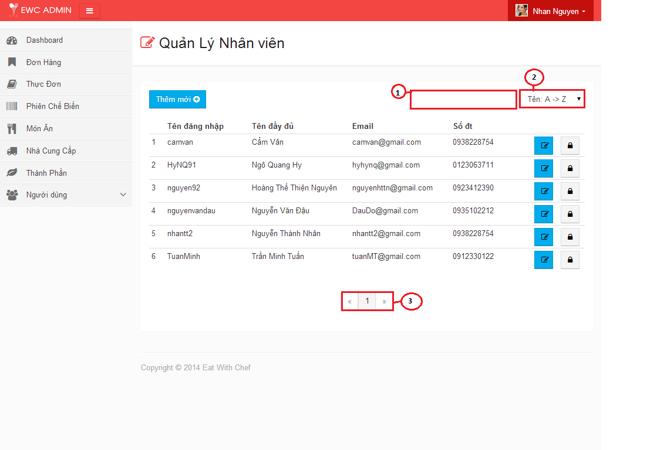

| **STEP** | **DESCRIPTION** |
| --- | --- |
| **1** | Type keyword to search for User. |
| **2** | Select one option to sort all result User. |
| **3** | Select page of result list that user want to visit. |

##### 4.2.1.12 Create Staff



| **STEP** | **DESCRIPTION** |
| --- | --- |
| **1** | Fill “Tên đăng nhập” field (required) |
| **2** | Fill “Mật khẩu” field (required) |
| **3** | Fill “Xác nhận Mật khẩu” field (required) |
| **4** | Fill “Tên đầy đủ” field (required) |
| **5** | Fill “Email” field (required) |
| **6** | Fill “Số điện thoại” field (required) |
| **7** | Select one option of “Giới tính”. |
| **8** | Fill “Ngày sinh” field (required) |
| **9** | Fill “Địa chỉ” field (required) |
| **10** | Click “Lưu” button. |
| **5** | Choose value for “Truy Nguyên”. |
| **6** | Click “Thêm” button |

##### 4.2.1.12 Create Chef



| **STEP** | **DESCRIPTION** |
| --- | --- |
| **1** | Fill “Tên đăng nhập” field (required) |
| **2** | Fill “Mật khẩu” field (required) |
| **3** | Fill “Xác nhận Mật khẩu” field (required) |
| **4** | Fill “Tên đầy đủ” field (required) |
| **5** | Fill “Email” field (required) |
| **6** | Fill “Số điện thoại” field (required) |
| **7** | Select one option of “Giới tính”. |
| **8** | Fill “Ngày sinh” field (required) |
| **9** | Fill “Địa chỉ” field (required) |
| **10** | Click “Tiếp tục” button |

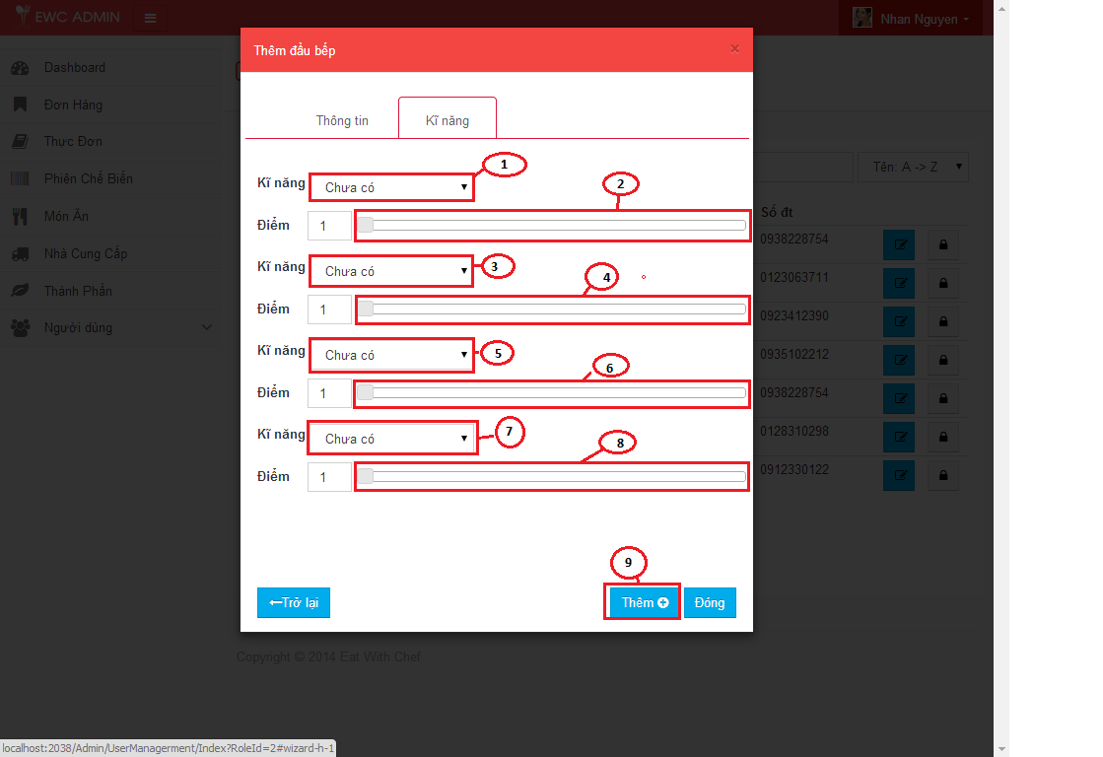

| **STEP** | **DESCRIPTION** |
| --- | --- |
| **1** | Select one option of “Kĩ năng” field. |
| **2** | Choose score of first skill. |
| **3** | Select one option of “Kĩ năng” field. |
| **4** | Choose score of second skill. |
| **5** | Select one option of “Kĩ năng” field. |
| **6** | Choose score of thirst skill. |
| **7** | Select one option of “Kĩ năng” field. |
| **8** | Choose score of last skill. |
| **9** | Click “Thêm” button |

##### 4.2.1.12 Edit skill of Chef

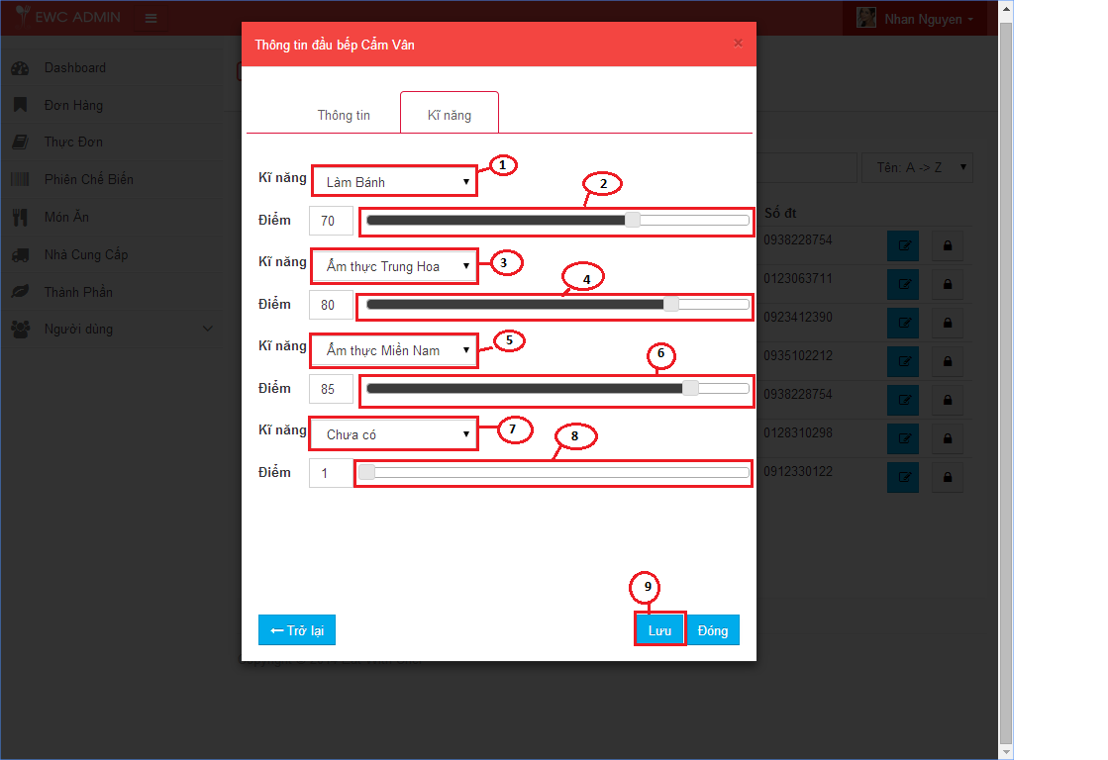

| **STEP** | **DESCRIPTION** |
| --- | --- |
| **1** | Edit option of “Kĩ năng” field. |
| **2** | Edit score of first skill. |
| **3** | Edit one option of “Kĩ năng” field. |
| **4** | Edit score of second skill. |
| **5** | Edit one option of “Kĩ năng” field. |
| **6** | Edit score of thirst skill. |
| **7** | Edit one option of “Kĩ năng” field. |
| **8** | Edit score of last skill. |
| **9** | Click “Lưu” button |

##### 4.2.1.12 Deactive User

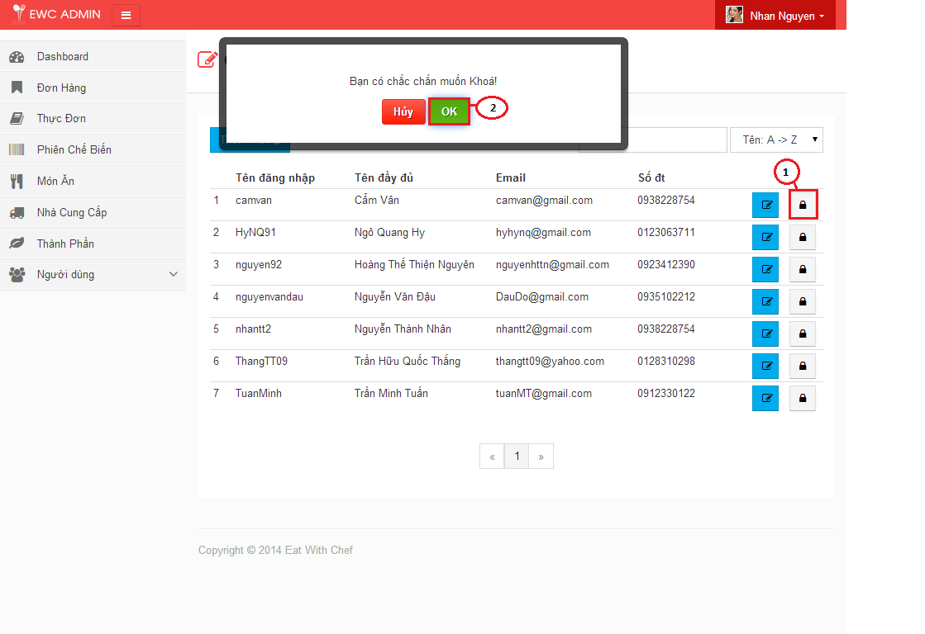

| **STEP** | **DESCRIPTION** |
| --- | --- |
| **1** | Click trash button. |
| **2** | Click “Ok” button to confirm deactive. |

##### 4.2.1.12 Active User

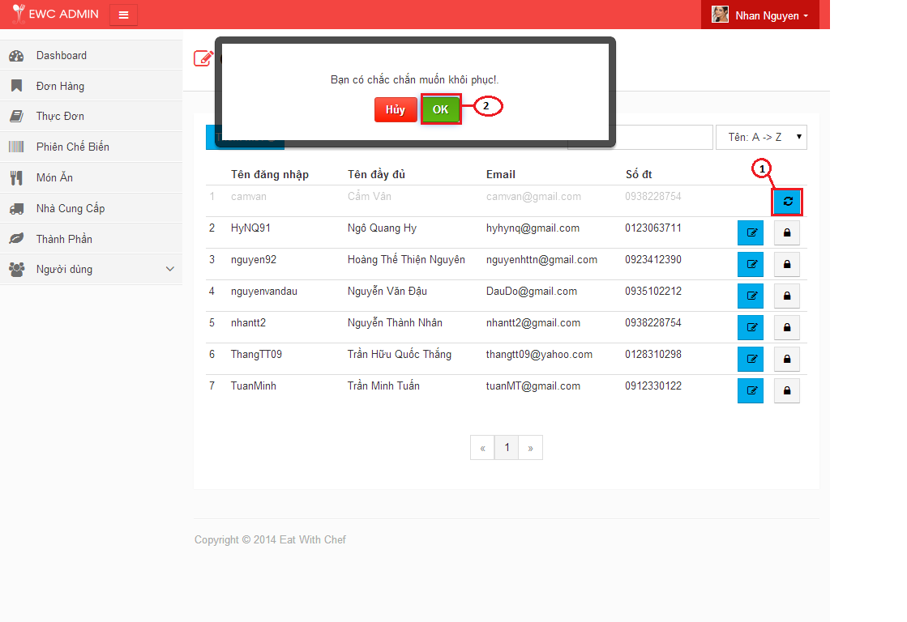

| **STEP** | **DESCRIPTION** |
| --- | --- |
| **1** | Click refesh button. |
| **2** | Click “Ok” button to confirm active. |

##### 4.2.1.12 Show supplier

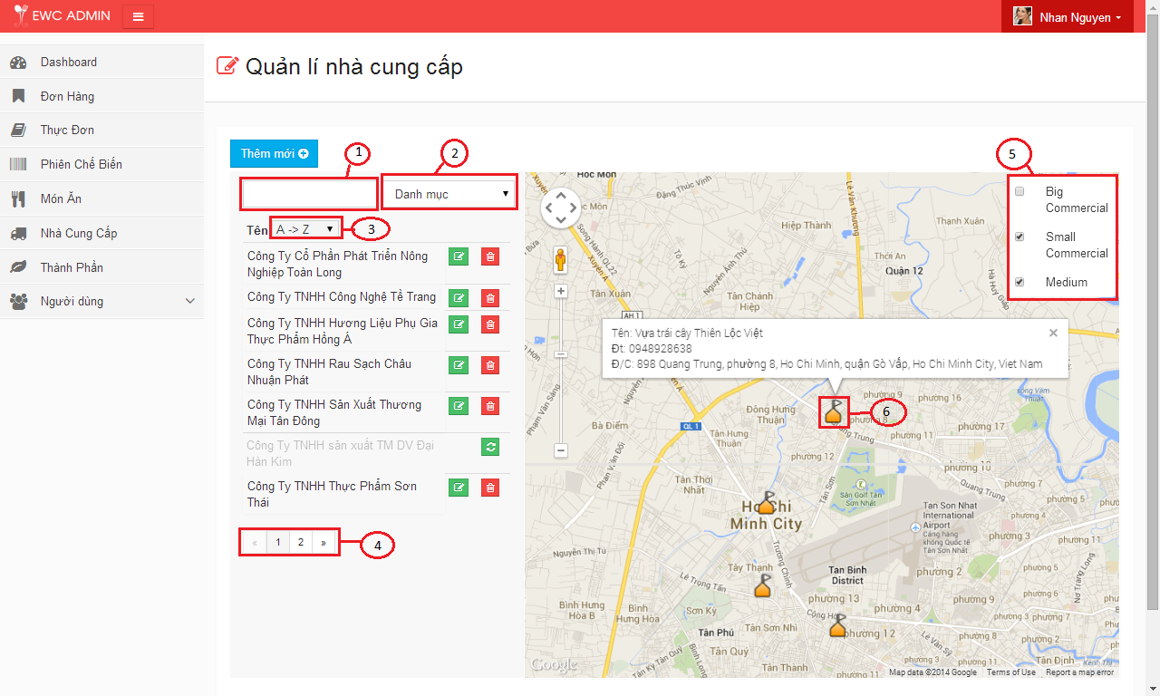

| **STEP** | **DESCRIPTION** |
| --- | --- |
| **1** | Type keyword to search for supplier |
| **2** | Select one option to filter supplier by Category. |
| **3** | Select one option to sort all result supplier. |
| **4** | Select page of result list that user want to visit. |
| **5** | Click on category to view supplier on google map. |
| **6** | Click on Marker to view information of supplier. |

##### 4.2.1.12 Create supplier

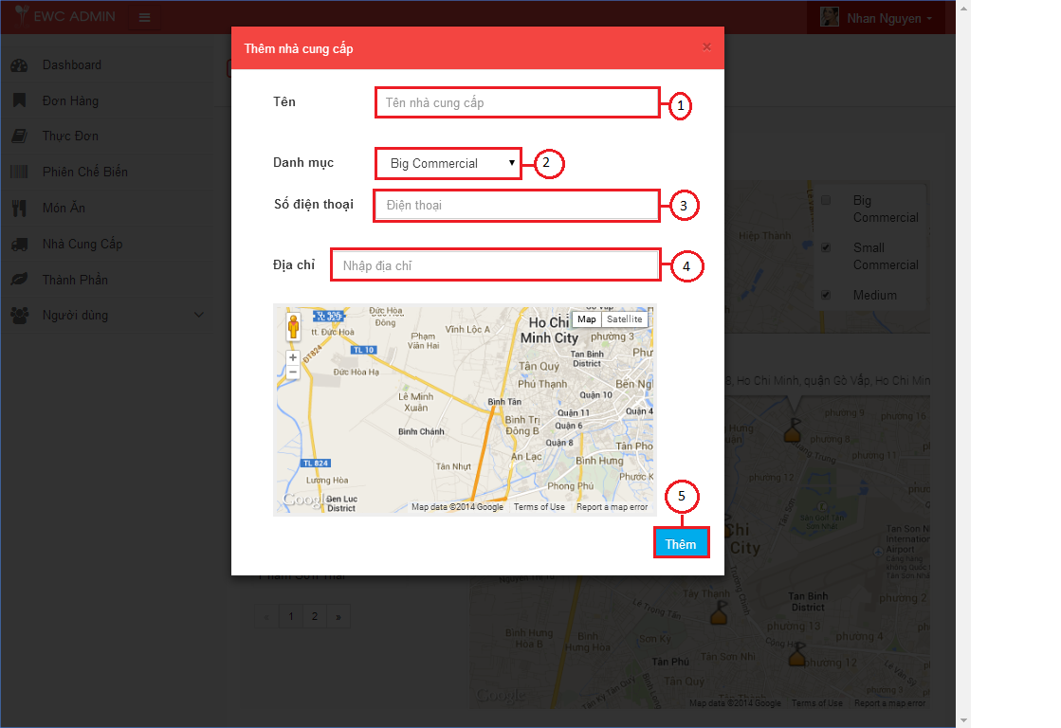

| **STEP** | **DESCRIPTION** |
| --- | --- |
| **1** | Fill “Tên” field (required) |
| **2** | Select one option of “Danh mục” field |
| **3** | Fill “Số điện thoại” field (required) |
| **4** | Fill “Địa chỉ” field (required). |
| **5** | Click “Thêm” button |

##### 4.2.1.12 Update information of supplier

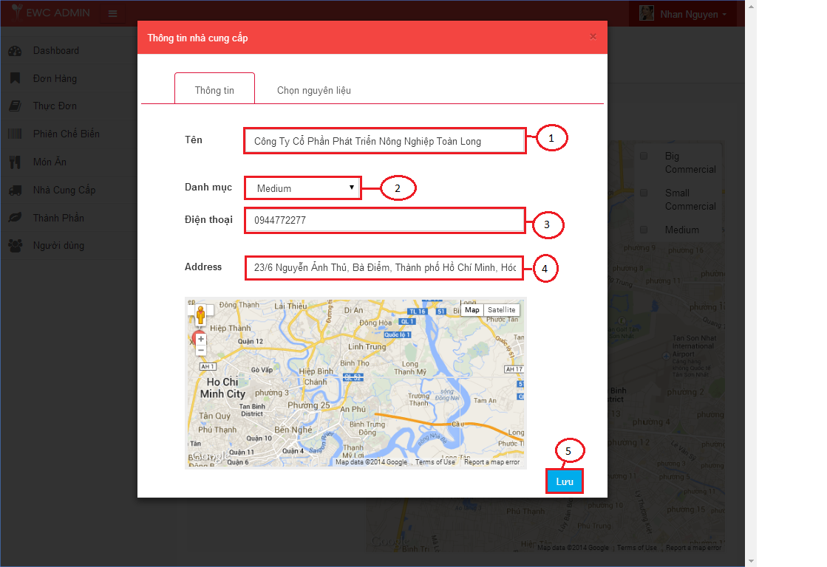

| **STEP** | **DESCRIPTION** |
| --- | --- |
| **1** | Fill “Tên” field (required) |
| **2** | Select one option of “Danh mục” field |
| **3** | Fill “Số điện thoại” field (required) |
| **4** | Fill “Địa chỉ” field (required). |
| **5** | Click “Lưu” button |

##### 4.2.1.12 Edit Ingredient of supplier

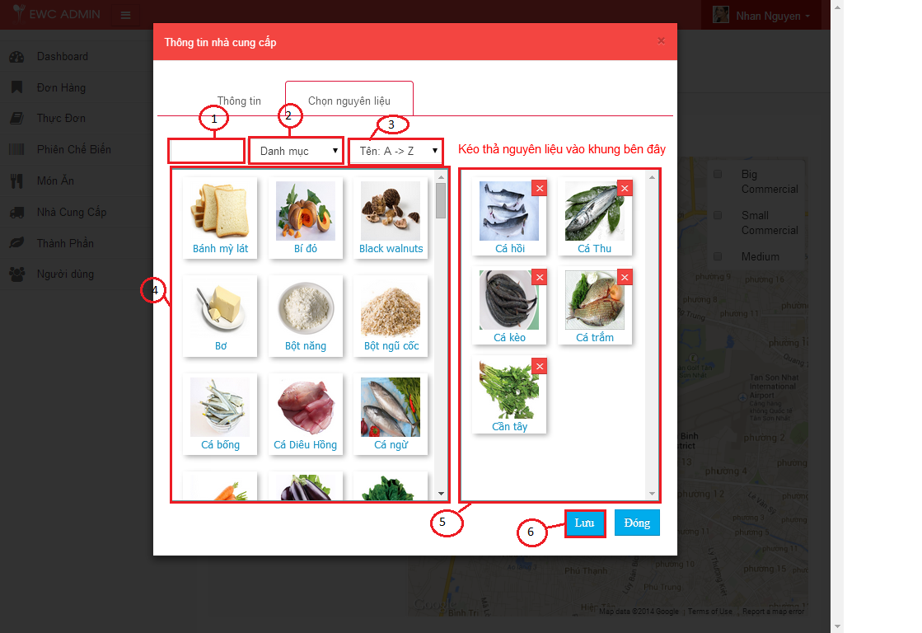

| **STEP** | **DESCRIPTION** |
| --- | --- |
| **1** | Type in keyword want to search for Ingredient |
| **2** | Select one option to filter Ingredient Category |
| **3** | Select one option to filter result. |
| **4** | Drag Ingredients to the right container |
| **5** | Click delete button on ingredient to remove. |
| **6** | Click “Lưu” button |

##### 4.2.1.12 Update supplier default of ingredient.

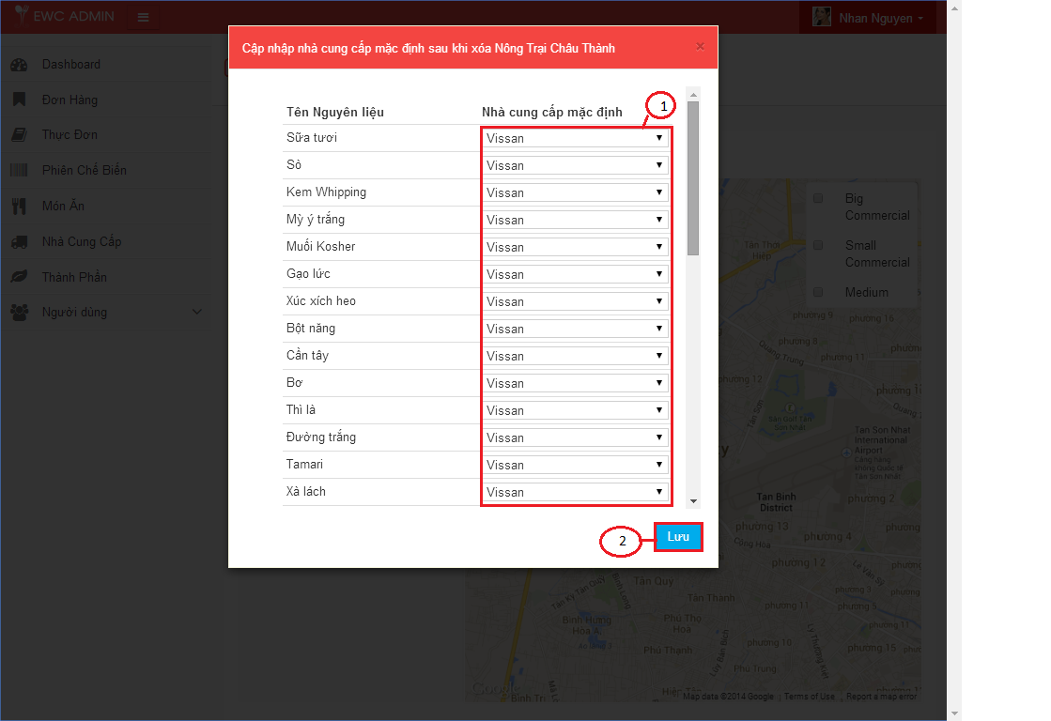

| **STEP** | **DESCRIPTION** |
| --- | --- |
| **1** | Select option for Supplier default. |
| **2** | Click “Lưu” button |

##### 4.2.1.12 Delete supplier

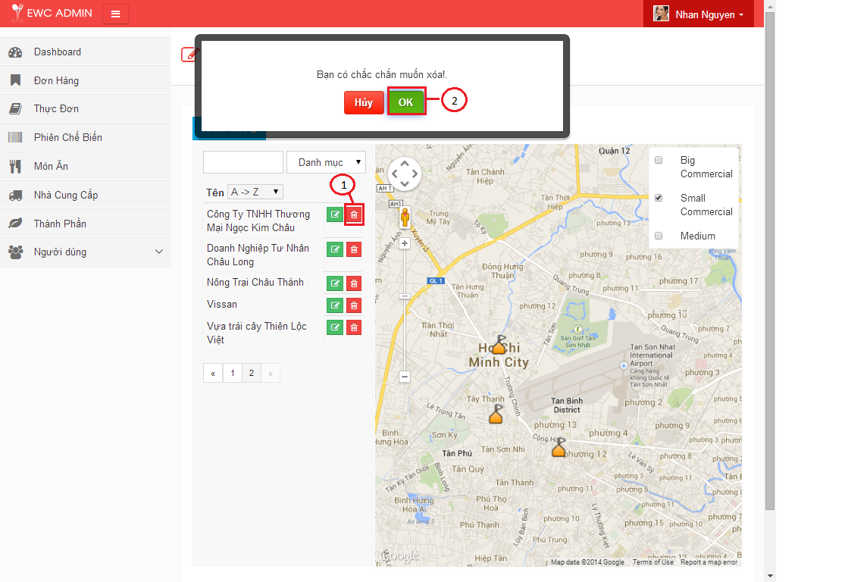

| **STEP** | **DESCRIPTION** |
| --- | --- |
| **1** | Click trash button. |
| **2** | Click “Ok” button to confirm delete. |

##### 4.2.1.12 Active supplier

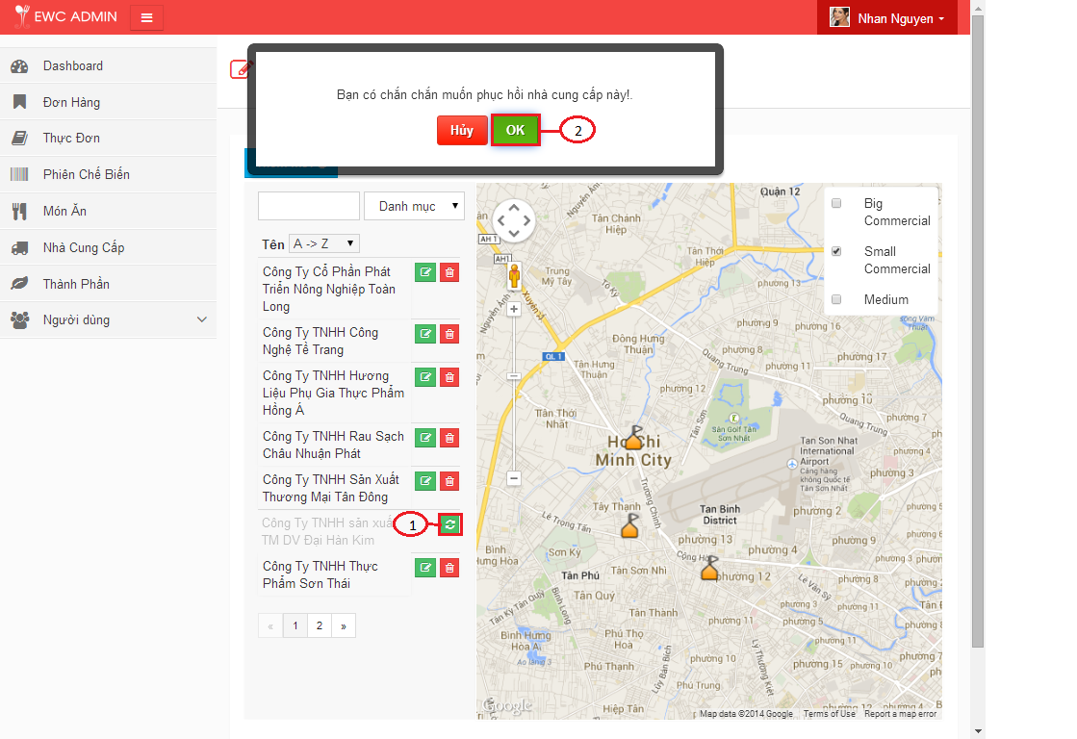

| **STEP** | **DESCRIPTION** |
| --- | --- |
| **1** | Click refesh button. |
| **2** | Click “Ok” button to confirm active. |